Outcomes of the Cochrane Skin Prioritisation Exercise 2020
Helen Scott and Liz Doney, on behalf of
Cochrane Skin

Contents
1 Introduction 6
1.1 Methodology 6
1.2 Global Burden of Disease 6
1.3 CENTRAL search: identifying disease areas in which new clinical trials have been reported 6
Table 1: Topic areas where >200 references were retrieved from CENTRAL, allowing analysis using VOSViewer text mining software 7
1.4 Recent metrics used to rank Cochrane Skin reviews 7
Table 2: A matrix showing which Cochrane Skin intervention reviews appeared in the top ten results of the 3 metrics considered (full text downloads, citations and Altmetric scores) 7
1.5 How this document is organised 9
2 Atopic Dermatitis (eczema) 10
2.1 Summary table 10
2.2 New records of clinical trials published 2017-2019 16
2.3 Eczema and dermatitis VOSViewer map 17
2.4 A matrix showing which existing eczema and dermatitis intervention reviews appeared in the top ten results of the 3 metrics considered (full text downloads, citations and Altmetric scores) 17
2.5 Eczema – summary 18
3 Psoriasis 19
3.1 Summary table 19
3.2 New records of clinical trials published 2017-2019 23
3.3 Psoriasis VOSViewer map 24
3.4 A matrix showing which existing psoriasis intervention reviews appeared in the top ten results of the 3 metrics considered (full text downloads, citations and Altmetric scores) 24
3.6 Psoriasis - summary 25
4 Urticaria 26
4.1 Summary table 26
4.2 New records of clinical trials published 2017-2019 26
4.3 Urticaria – summary 26
5 Fungal infections of skin, nails and scalp 27
5.1 Summary table 27
5.2 New records of clinical trials published 2017-2019 28
5.3 A matrix showing which existing fungal infection of the nails, skin and scalp intervention reviews appeared in the top ten results of the 3 metrics considered (full text downloads, citations and Altmetric scores) 28
5.4 Fungal infections of skin, nails and scalp – summary 28
6 Viral infections of the skin 29
6.1 Summary table 29
6.2 New records of clinical trials published 2017-2019 30
6.3 Infectious diseases VOSViewer map 30
6.4 A matrix showing which existing viral infection intervention reviews appeared in the top ten results of the 3 metrics considered (full text downloads, citations and Altmetric scores) 31
6.5 Viral skin infections – summary 31
7 Acne vulgaris 32
7.1 Summary table 32
7.2 New records of clinical trials published 2017-2019 36
7.3 Acne VOSViewer map 37
7.4 A matrix showing which existing psoriasis intervention reviews appeared in the top ten results of the 3 metrics considered (full text downloads, citations and Altmetric scores) 37
7.5 Acne vulgaris – summary 38
8 Bacterial infections of the skin (pyoderma and cellulitis) 39
8.1 Summary table 39
8.2 New records of clinical trials published 2017-2019 41
8.3 A matrix showing which existing pyoderma and cellulitis intervention reviews appeared in the top ten results of the 3 metrics considered (full text downloads, citations and Altmetric scores) 41
8.4 Bacterial skin infections – summary 41
9 Contact Dermatitis 42
9.1 Summary table 42
9.2 New records of clinical trials published 2017-2019 42
9.3 A matrix showing which existing contact dermatitis intervention reviews appeared in the top ten results of the 3 metrics considered (full text downloads, citations and Altmetric scores) 42
9.4 Contact dermatitis – summary 42
10 Skin Cancer 43
10.1 Malignant skin melanoma 43
10.2 Non-melanoma skin cancer 43
10.3 Summary table 43
10.4 New records of clinical trials published 2017-2019 47
10.5 Skin cancer VOSViewer map 48
10.6 A matrix showing which existing skin cancer intervention reviews appeared in the top ten results of the 3 metrics considered (full text downloads, citations and Altmetric scores) 48
10.7 Skin cancer – summary 49
11 Pruritus 50
11.1 Summary table 50
11.2 New records of clinical trials published 2017-2019 50
11.3 Pruritus – summary 50
12 Alopecia areata 51
12.1 Summary table 51
12.2 New records of clinical trials published 2017-2019 54
12.3 A matrix showing which existing alopecia intervention reviews appeared in the top ten results of the 3 metrics considered (full text downloads, citations and Altmetric scores) 55
12.4 Alopecia areata – summary 55
13 Cutaneous and mucocutaneous leishmaniasis 56
13.1 Summary table 56
13.2 New records of clinical trials published 2017-2019 56
13.3 Infectious diseases (including leishmaniasis records) VOSViewer map 57
13.4 A matrix showing which existing leishmaniasis intervention reviews appeared in the top ten results of the 3 metrics considered (full text downloads, citations and Altmetric scores) 57
13.5 Cutaneous leishmaniasis – summary 57
14 Seborrhoeic dermatitis 58
14.1 Summary table 58
14.2 New records of clinical trials published 2017-2019 58
15 Leprosy 58
15.1 Summary table 58
15.2 New records of clinical trials published 2017-2019 58
16 Other skin and subcutaneous diseases (includes e.g. bullous diseases, connective tissue diseases, and cutaneous drug reactions) 59
16.1 Summary table 59
16.2 A matrix showing which existing intervention reviews related to other CS scope topics appeared in the top ten results for the 3 metrics considered (full text downloads, citations and Altmetric scores) 71
16.3 Other VOSViewer maps 71
16.4 Other skin diseases – summary 72
16.5 Suggestions received during prioritisation which are not within Cochrane Skin scope 73
Appendix 1 74
The Cochrane Skin prioritisation survey 74
Table 3: Organisations invited to participate in the CS online survey 75
Table 4: Summary of responses to Question 3: I am answering the survey from the perspective of… 76
Appendix 2 76
Table 5: Disability-adjusted life year (DALY) rate per 100 000 persons from 15 skin disease categories throughout 21 world regions, together with their global prevalence 76
References to James Lind Alliance Priority Setting Partnerships and NICE research recommendations 77
Appendix 3 78
Search strategy used for CENTRAL. Results were limited to records added to CENTRAL between 2017 and 2019 78
Limitations of the search 80
Screen shots showing EndNote folders 81
Appendix 4 81
Limitations of VOSViewer maps 81
VOSViewer map showing high frequency words across all records retrieved from CENTRAL related to the scope of Cochrane Skin 82

Introduction
A comprehensive exercise in setting priorities for undertaking new Cochrane Skin (CS) reviews was undertaken in the first quarter of 2020. This exercise follows on from a previous project prioritising review titles undertaken in 2017.

  - Methodology
We used the same mixed methods that we used in our first prioritisation exercise in 2017, with the addition of points 4 and 5 below:
- We contacted professional societies, guideline development groups, the CS membership and patient representatives to ask for review title suggestions, using an online survey tool (Survey Monkey). The text of the survey including the questions asked, a list of the organisations contacted, and a summary of respondents, is shown in Appendix 1. We also included suggestion from our South American Satellite and those suggested by email since 2017.
- We reviewed prioritisation exercises relevant to our scope undertaken by the James Lind Alliance (JLA) and others. We also reviewed suggestions for research made by national and international guideline groups.
- We analysed Global Burden of Disease data for disease areas within our scope.
- We undertook a search of CENTRAL to identify recently published reports of studies within our scope.
- We collated download information, citation data and Altmetric scores for our existing portfolio of review titles.
  - Global Burden of Disease
The Global Burden of Disease (GBD) provides a tool to quantify health loss from hundreds of diseases, injuries, and risk factors; the data capture premature death and disability from more than 350 diseases and injuries in 195 countries, by age and sex, from 1990 to 2017, allowing comparisons over time, across age groups, and among populations. The most up-to-date data for 2017 can be queried using the GBD results tool. Disability-Adjusted Life Year (DALY) data for ‘Skin and subcutaneous diseases’ (excluding scabies and decubitus ulcer, not within Cochrane Skin scope) plus skin cancer, leprosy and cutaneous and mucocutaneous leishmaniasis, were downloaded. This data can be found in Appendix 2.
  - CENTRAL search: identifying disease areas in which new clinical trials have been reported
Our Information Specialist searched CENTRAL from 2017 to 2019 in order to identify recent reports of trials within the scope of Cochrane Skin. She adapted a search strategy created by Douglas Grindlay at the Centre of Evidence Based Dermatology, which aims to identify all systematic reviews published in the field of dermatology (see Appendix 3 for strategy, where limitations of the search are also outlined). The search results were exported and categorised by disease area using EndNote software (see Appendix 3 for screenshots showing the EndNote folders). In disease areas with a high number of retrieved references (> 200), we were able to export the titles and abstracts of the references retrieved and use VOSViewer text mining software to analyse the intervention terms most frequently occurring in the text (see Table 1).

Table 1: Topic areas where >200 references were retrieved from CENTRAL, allowing analysis using VOSViewer text mining software
Topic | Number of records retrieved from CENTRAL
All retrieved references | 4,594
Skin cancer* | 1,074
Psoriasis | 885
Eczema and dermatitis** | 548
Connective tissue disorders | 370
Wrinkles, skin ageing, photoageing… | 329
Acne | 227
Infectious diseases*** | 222
*Skin cancer includes actinic keratosis (94), NMSC (276), malignant melanoma (583), Kaposi sarcoma (6), mycosis fungoides etc (56), skin cancer screening etc (66), lentigo maligna (3), merkel cell (10).
**Eczema and dermatitis includes eczema including hand (107), atopic dermatitis (374), contact dermatitis (25), drug reactions and radiation dermatitis (22), seborrheic dermatitis (6).
***Infectious diseases includes bacterial diseases (32), fungal skin diseases (59), leprosy (6), infectious diseases (87) and warts (39).
NB Some records appear in two folders, hence discrepancies in totals.
The maps created using VOSViewer for the above topics appear in the report below. See Appendix 4 for limitations to consider when looking at the maps, and for a map created based on all the references retrieved by the search, e.g. the full scope of Cochrane Skin.
  - Recent metrics used to rank Cochrane Skin reviews
Metrics relating to 2017 and 2018 for Cochrane Skin reviews have been analysed to identify our most downloaded, most cited and highest scoring (in terms of Altmetric score) titles. Wiley provided the data, which are the most up to date available at January 2020 (see Table 1 below).
These data provide a snapshot of which CS reviews have been in most in demand and have received most attention. Note that the data are affected by various criteria including the date of publication of the review, and open access status. Citation and Altmetric data can be subject to interpretation and manipulation and should be used with caution. Table 1 gives an indication of which reviews may be candidates for future updates, but does not help to identify evidence gaps, or give any indication of where new systematic review titles should be commissioned.

Table 2: A matrix showing which Cochrane Skin intervention reviews appeared in the top ten results of the 3 metrics considered (full text downloads, citations and Altmetric scores)
Review title | Combined download totals 2017 & 2018 | Highest citations 2017 or 2018 | Highest altmetric scores 2017 or 2018 | Total
Emollients and moisturisers for eczema | X | X | X | 3
Systemic pharmacological treatments for chronic plaque psoriasis: a network meta-analysis | X | X | X | 3
Drugs for discoid lupus erythematosus |  | X | X | 2
Interventions for acne scars | X | X |  | 2
Interventions for cutaneous molluscum contagiosum |  | X | X | 2
Interventions for female pattern hair loss | X | X |  | 2
Interventions for rosacea | X | X |  | 2
Interventions for vitiligo | X | X |  | 2
Light therapies for acne | X | X |  | 2
Oral antifungal medication for toenail onychomycosis |  | X | X | 2
Complementary therapies for acne vulgaris | X |  |  | 1
House dust mite reduction and avoidance measures for treating eczema |  | X |  | 1
Interventions for hidradenitis suppurativa |  | X |  | 1
Interventions for infantile haemangiomas of the skin |  |  | X | 1
Interventions for necrotizing soft tissue infections in adults |  |  | X | 1
Interventions for Old World cutaneous leishmaniasis |  |  | X | 1
Interventions for preventing occupational irritant hand dermatitis |  |  | X | 1
Interventions for the prevention of recurrent erysipelas and cellulitis |  |  | X | 1
Leukotriene receptor antagonists for eczema |  |  | X | 1
Oral isotretinoin for acne |  |  | X | 1
Probiotics for treating eczema |  |  | X | 1
Sentinel lymph node biopsy followed by lymph node dissection for localised primary cutaneous melanoma |  | X |  | 1
Specific allergen immunotherapy for the treatment of atopic eczema |  | X |  | 1
Systemic antifungal therapy for tinea capitis in children |  | X |  | 1
Systemic treatments for metastatic cutaneous melanoma |  |  | X | 1
Topical antifungal treatments for tinea cruris and tinea corporis | X |  |  | 1
Topical azelaic acid, salicylic acid, nicotinamide, sulphur, zinc and fruit acid for acne | X |  |  | 1
Topical tacrolimus for atopic dermatitis |  | X |  | 1
Topical treatments for scalp psoriasis |  | X |  | 1
  - How this document is organised
This document is organised by skin disorder, or group of skin disorders, with those listed as having the highest global burden in the Global Burden of Disease (GBD) data first; followed by ‘other’ skin disorders and suggestions.
Each skin disorder (or group of disorders) has a separate table with:
- a summary of all review title suggestions from the survey data, and their attribution;
- a summary of any Priority Setting Partnerships related to each disease, and research priorities identified by the UK National Institute for Health and Care Excellence (NICE) (where available);
- the titles of existing CS reviews relevant to the disorder.
In addition, for each disease we have provided:
- the number of records retrieved from the CENTRAL search for the disorder(s), (a rough indicator of the number of reports of trials recently published in the field);
- a VOSViewer map highlighting intervention terms (if sufficient references were available); and
- data on downloads, citations and Altmetric scores for titles related to the disorder already in the current CS portfolio.
To make evaluation of this document easier, we have summarised areas which have been suggested as priorities, in a brief paragraph at the end of the text for each skin condition.

Atopic Dermatitis (eczema)
The number of DALYs 2017 for atopic dermatitis is 9,003,374, with a global prevalence of 2.79%.
  - Summary table
SR title suggestions from the survey | Current Cochrane Skin titles in this area | Research priorities
Atopic dermatitis  The pharmaceutical industry is undertaking large phase III trials; the literature is evolving  Clinical society, association or professional organisation (British Association of Dermatologists' Therapy & Guidelines sub-committee) |  | JLA health professionals’ research priority: Which is most effective in the management of eczema: education programmes, GP care, nurse-led care, dermatologist-led care or multidisciplinary care?  AAD guidelines gaps in research (not covered in areas below):  - comparative trials of various phototherapy methods and dosage protocols, maintenance requirements for phototherapy.  - comparative studies to decide on best agents for long-term maintenance therapy; and trials assessing outcomes of allergic contact dermatitis testing and avoidance measures in AD patients.
Microbiome in atopic eczema  Issues and questions that I have regularly in my clinical practice  Clinician/healthcare professional  IPD of probiotics/prebiotics for prevention of eczema  Because the question has never been answered properly in terms of strain, dose and timing  Researcher | #102 Probiotics for treating eczema (2018)
Efficacy of emollients to treat dry skin associated with eczema  Health commissioners questioning the value of evidence for emollients and limiting prescribing.  Patient group or consumer group  Emollient use and effectiveness in treatment of eczema  To clarify the best protocols for management of eczema in adults  Patient/Consumer | #124 Emollients for eczema (2017) | JLA top shared priority: Which emollient is the most effective and safe in treating eczema?  JLA health professionals’ research priority: Which should be applied first when treating eczema, emollients or topical steroids?
Topical steroid treatment of eczema  To clarify the best protocols for management of eczema in adults  Patient/Consumer  Comparative review of efficacy of topical drug treatments for eczema - topical corticosteroids vs topical calcineurin inhibitors  Poor current evidence base  Patient group or consumer group | #141 Different strategies for using topical corticosteroids for established eczema (protocol 2019)  #174 Topical treatments for eczema: a network meta-analysis (protocol 2019, on hold) | JLA top shared priority: What is the best and safest way of using topical steroids for eczema: frequency of application, potency, length of time, alternating with other topical treatments, and age limits for treatment?  JLA health professionals’ research priority: Which is safer and more effective for treating eczema: steroids or calcineurin inhibitors?
Safety of topical corticosteroids  Amongst patients/consumers adverse reactions are reported and concern is seen within consumer groups.  Patient/Consumer & Researcher  Should more potent topical steroids be considered as first line treatment in children?  Would using more potent steroid be more harmful if quicker control of eczema  Clinician/healthcare professional?  How many people actually suffer side effects of topical steroids?  Major concerns for patients using steroids  Clinician/healthcare professional  Side Effects of topical steroids on the skin especially related to length of treatment  There isn’t a lot of good research on the long term effects on the skin and the problems of using long term  Patient/Consumer  Topical steroid withdrawal (red skin syndrome)  I have been going through this condition and have not had a lot of support from the medical community as it is not widely recognised. It would be great to have some validated research to inform doctors and healthcare professionals  Patient/Consumer  No moisture treatment (in relation to red skin syndrome)  A relatively new and not widely recognised treatment for red skin syndrome which has been incredibly helpful for myself.  Patient/Consumer  Topical steroid withdrawal  Mismanagement of eczema with topical steroids is causing patients and care givers to suffer for years; doctors do not know enough about tsw; strict guidance needs to be in place to prevent prescription of topical steroids for more than 2 weeks  Patient/Consumer  Safety of topical corticosteroids in pregnancy  Provide 'right care' for pregnant women  Clinician/healthcare professional | #119 Safety of topical corticosteroids in pregnancy (2015) | JLA top shared priority: What is the long-term safety of applying steroids to the skin for eczema?  JLA health professionals’ research priority: Which is safer and more effective for treating eczema: steroids or calcineurin inhibitors?  NICE research recommendations (under 12s: diagnosis and management):  4. What are the long-term effects (when used for between 1 and 3 years) of typical use of topical corticosteroids in children with atopic eczema?
Topical tacrolimus for atopic eczema  High impact for individuals, Potential harm with incorrect treatment, Need for evidence for funders at all levels  Clinician/healthcare professional  Update - Topical tacrolimus for atopic dermatitis  Include new studies  Patient/Consumer & Researcher  Primary care uses of topical calcineurin inhibitors (as steroid sparing alternative in all its guises)  TCIs widely used by dermatologists and GPwERs but CCG pharmacists are very concerned about GPs prescribing them  Clinician/healthcare professional & Guideline developer (PCDS) | #69 Topical tacrolimus for atopic dermatitis (2015)  now part of:  #174 Topical treatments for eczema: a network meta-analysis (protocol 2019, on hold) | JLA health professionals’ research priority: Which is safer and more effective for treating eczema: steroids or calcineurin inhibitors?  AAD guidelines gaps in research: well-designed, large trials to better test the effects of topical antimicrobial agents and TCS-TCI in combination; increased long-term safety data for intermittent use of TCS and TCI; and studies to provide additional long-term safety data on the use of TCI.
Efficacy of antiseptic measures (e.g. bleach baths, salt baths, antimicrobial emollients) to prevent infection in people with infected eczema  Poor current evidence base  Patient group or consumer group | #43 Interventions to reduce Staphylococcus aureus in the management of atopic eczema (2019) | JLA health professionals’ research priority: How effective are interventions to reduce skin infections in the management of eczema?
Living NMA IPD on biologics for atopic dermatitis  Because there will lots of good new data amenable to IPD and about 20 new drugs coming on line all compared to placebo  Researcher  New Interventions for Atopic dermatitis (Dupilumab)  South American Satellite  The use of novel biological treatments for eczema  To clarify the effectiveness v side effects of biological treatments  Patient/Consumer  Eczema injections  To keep us up to date and give us some hope  Patient/Consumer | #175 Systemic treatments for eczema: a network meta-analysis prioritised in 2017) | JLA health professionals’ research priority: What is the best and safest way of using drugs that suppress the immune system when treating eczema?  AAD guidelines gaps in research: comparative studies of systemic immunomodulating medications, optimal dose and duration of systemic immunomodulating medications, and drug trials in pediatric patients.
Efficacy of psychological interventions in treatment of eczema symptoms  Limited comparative evidence base  Patient group or consumer group  Eczema and mental health  Because they have the potential to engage or disengage whole groups of the community  Patient/Consumer  Psychodermatology interventions for the treatment of atopic dermatitis in adults (potentially update children)  Potential to support the first-line and second-line intervention  Patient/Consumer & Researcher | #44 Psychological and educational interventions for atopic eczema in children (2014)  #167 Psychological and educational interventions for atopic eczema in adults (protocol submitted, title withdrawn) | JLA patients and carers’ research priority: What is the best psychological treatment for itching ⁄ scratching in eczema?  NICE research recommendations (under 12s: diagnosis and management):  5. How effective and cost effective are different models of educational programmes in the early management of atopic eczema in children, in terms of improving adherence to therapy and patient outcomes such as disease severity and quality of life?
Complementary & alternative medicines for atopic dermatitis  Patients are likely to look to alternative treatments which they consider less invasive than medical intervention  Patient/Consumer & Researcher  Acupuncture for atopic dermatitis  Title suggestion by email since last exercise | #17 Chinese herbal medicine for atopic eczema (2013, stable)  #148 Complementary and alternative medicine treatments for atopic eczema (protocol 2014, team withdrew)  #53 Oral evening primrose oil and borage oil for atopic eczema (2013, stable) | JLA patients and carers’ research priority: What are the best and safest natural products to apply to the skin for eczema?  AAD guidelines gaps in research: Additional large, well-controlled trials are needed to test the effects of adjunctive treatments showing positive data, including… complementary therapies.
Dietary exclusions for established atopic eczema  Common question, still topical, review out of date  Clinician/healthcare professional Researcher  Eczema and diet  Because they have the potential to engage or disengage whole groups of the community  Patient/Consumer  Dietary supplements for established atopic eczema  Question often asked, review out of date  Clinician/healthcare professional Researcher  Update - Dietary supplements for established atopic eczema  Include new studies  Patient/Consumer & Researcher | #31 Dietary exclusions for established atopic eczema (2008)  #91 Dietary supplements for established atopic eczema (2012) | JLA patients and carers’ research priority: What is the role of diet in treating eczema: exclusion diets and nutritional supplements?  AAD guidelines gaps in research: Additional large, well-controlled trials are needed to test the effects of adjunctive treatments showing positive data, including vitamins D and E.
Efficacy of prescription garments in the treatment of severe eczema  Too much emphasis placed on a single study (CLOTHES), which has significant limitations in adherence achieved, patient recruitment and outcome measurement.  Patient group or consumer group |  | AAD guidelines gaps in research: Additional large, well-controlled trials are needed to test the effects of adjunctive treatments showing positive data, including… specialized clothing fabrics.
Atopic dermatitis in infants  Clear best practice guidelines yet to be formulated  Clinician/healthcare professional  Eczema development in older adults (65+)  To clarify the hormonal link to eczema in women  Patient/Consumer  The role of oestrogen in development/flaring of eczema  To clarify the hormonal link to eczema in women  Patient/Consumer |  | NICE research recommendations (under 12s: diagnosis and management):  1. What is the optimal feeding regimen in the first year of life for children with established atopic eczema?  2. Which are the best, most cost-effective treatment strategies for managing and preventing flares in children with atopic eczema?
 | #172 Skin care interventions in infants for preventing eczema and food allergy (protocol 2020)  #130 House dust mite reduction and avoidance measures for treating eczema (2015)  #128 Specific allergen immunotherapy for the treatment of atopic eczema (2016) | JLA top shared priority: What role might food allergy tests play in treating eczema?  NICE research recommendations (under 12s: diagnosis and management):  3. What effect does improving the control of atopic eczema in the first year of life have on the long-term control and severity of atopic eczema and the subsequent development and severity of food allergy, asthma and allergic rhinitis?  JLA patients and carers’ research priorities: What is the best way for people with eczema to wash: frequency of washing, water temperature, bath vs. shower?  How much does avoidance of irritants and allergens help people with eczema?  AAD guidelines gaps in research: RCTs to better determine optimal bathing techniques, including controlled studies on frequency, duration, and the effects of bathing and use of bath emollients;  high-quality research on the role of foods and aeroallergens in AD with an emphasis on clear morphologic description of cutaneous reactions.  Additional large, well-controlled trials are needed to test the effects of adjunctive treatments showing positive data, including… immunotherapy for highly HDM-sensitized patients with persistent AD.
  - New records of clinical trials published 2017-2019
The search of CENTRAL identified 548 references relevant to eczema and dermatitis. These included references on hand eczema (107), atopic dermatitis (374), contact dermatitis (25), drug reactions and radiation dermatitis (22), and seborrheic dermatitis (6) (some records in more than one group, hence discrepancy in total).

  - Eczema and dermatitis VOSViewer map
The VOSViewer text mining software identified the following intervention terms as appearing most frequently in the title and abstract text of the 548 references from the search: emollient, cream, cyclosporine, moisturiser, crisaborole, ointment (see brightest yellow on the map below).
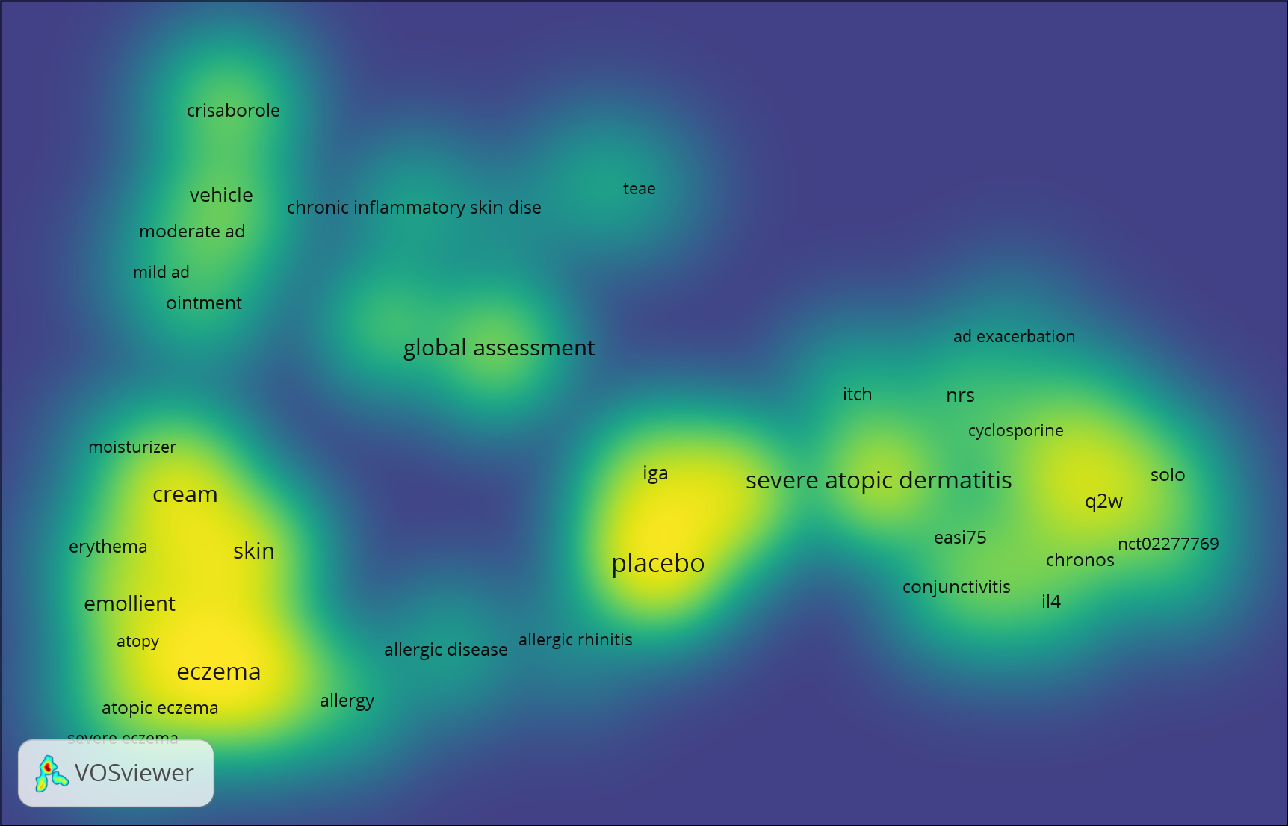
  - A matrix showing which existing eczema and dermatitis intervention reviews appeared in the top ten results of the 3 metrics considered (full text downloads, citations and Altmetric scores)
Review title | Combined download totals 2017 & 2018 | Highest citations 2017 or 2018 | Highest altmetric scores 2017 or 2018 | Total
Emollients and moisturisers for eczema | X | X | X | 3
House dust mite reduction and avoidance measures for treating eczema |  | X |  | 1
Interventions for preventing occupational irritant hand dermatitis |  |  | X | 1
Leukotriene receptor antagonists for eczema |  |  | X | 1
Probiotics for treating eczema |  |  | X | 1
Specific allergen immunotherapy for the treatment of atopic eczema |  | X |  | 1
Topical tacrolimus for atopic dermatitis |  | X |  | 1

  - Eczema – summary
Topic suggestions focus on eczema management. Several suggestions are already captured by the ongoing network meta-analysis of systemic treatments for eczema #175, which could potentially be extended as a living review in the same way as we have done for psoriasis with #156. One suggestion was to make it an individual participant data review. Other suggestions are already captured by the prioritised (but not yet successfully allocated to a team) network meta-analysis of topical treatments for eczema #174, which could potentially focus on steroids versus topical calcineurin inhibitors +/- newer topicals such as crisaborole and JAK inhibitors. Other suggestions are already captured by #141 on different strategies for using topical steroids.
New suggestions not currently being undertaken are:
A review which focuses on long-term maintenance treatment of eczema, rather than short term outcomes, including long-term safety of TCIs and TCS.
A focus on infancy – for diet, moisturisers, long-term effects of treatment with TCS/TCI
A targeted update of emollients for treating eczema #124 (2017)
Phototherapy for managing eczema
Testing and avoidance of contact allergens for managing eczema
Complementary medicine interventions, including acupuncture, for managing eczema
Psychological and educational interventions and models of care delivery for managing eczema - would these be materially different to psychological and educational interventions in other chronic conditions, and should this involve Cochrane groups/fields concerned with models for delivery of care?
Dietary exclusions for managing eczema – update of #31 (2008)
A review of environmental control/dust mite avoidance/ clothing – update of dust mite avoidance (2015)
An IPD of probiotics/prebiotics for prevention of eczema (Neonatal group have a title ‘Probiotics in infants for prevention of allergic disease and food hypersensitivity’)

Psoriasis
The number of DALYs 2017 for psoriasis is 5,569,471, with a global prevalence of 0.88%.
  - Summary table
SR title suggestions from the survey | Current Cochrane Skin titles in this area | Research priorities
Psoriasis  Guideline developer (AAD)  Psoriasis  Common disorder  Clinician/healthcare professional  Psoriasis  They help to standardize decision making regarding patient's diagnosis and treatment  Clinician/healthcare professional, Researcher  Treatment  Efficacy of treatment  Patient/Consumer |  | JLA PSP 2018 for psoriasis (including scalp and nail, excluding palmoplantar pustular)  2. Does treating psoriasis early (or proactively) reduce the severity of the disease, make it more likely to go into remission, or stop other health conditions developing?  3. What factors predict how well psoriasis will respond to a treatment?  4. What is the best way to treat the symptoms of psoriasis: itching, burning, redness, scaling and flaking?  6. Does treating psoriasis help improve other health conditions, such as psoriatic arthritis, cardiovascular disease, metabolic syndrome and stress?  7. Why do psoriasis treatments stop working well against psoriasis and when they stop working well, what’s the best way to regain control of the disease?  8. To what extent is psoriasis caused by a person’s genes or other factors, such as stress, gut health, water quality, or change in the weather / temperature?  9. Is a person with psoriasis more likely to develop other health conditions (either as a consequence of psoriasis or due to the effect of treatments for psoriasis)? If so, which ones?  10. What’s the best way to treat sudden flare ups of psoriasis?  NICE research recommendation: 5. Topical therapy: In people of all ages with psoriasis:  1. Assessment of disease severity and impact: In children, young people and adults with psoriasis, can tools be developed and/or existing ones further refined and validated to:  a. assess disease severity and impact in both non-specialist and specialist healthcare settings, to facilitate assessment, appropriate referral, treatment planning and measurement of outcomes  b. measure burden and cumulative effect of disease activity, severity and impact for people with both psoriasis and psoriatic arthritis?  4. Self-management: Do structured psoriasis-focused self-management programmes improve patient confidence, wellbeing and disease control compared with standard care?  AAD guidelines (comorbidities) gaps in research: to determine the impact of psoriasis treatment on the ability to prevent future disease associated comorbidity. Although emerging observational data of outcomes and experimental data of important surrogate markers hold promise for bending the comorbidity curve, large randomized controlled studies are necessary to determine which treatment strategies for psoriasis will lead to benefits for patients beyond the skin.
Microbiome in psoriasis
They reflect issues and questions that I have regularly in my clinical practice
Clinician/healthcare professional
Topical application  Efficacy of treatment  Patient/Consumer | #66 Topical treatments for chronic plaque psoriasis (2013)  #27 Topical treatments for scalp psoriasis (2016) | NICE research recommendation: 5. Topical therapy: In people of all ages with psoriasis:  a. How should topical therapies be used to maintain disease control i) safely; ii) effectively and iii) what are the health economic implications?  b. What are the risks of 'real life' long term corticosteroid use, are there particular people at risk and what strategies can be used to modify or avoid risks?
Oral treatment  Efficacy of treatment  Patient/Consumer | #90 Oral fumaric acid esters for psoriasis (2015), now included in:  #156 Systemic pharmacological treatments for chronic plaque psoriasis: network meta-analysis (2017, being updated as a living review)
Biologic agents sequencing in psoriasis  Unmet therapeutic need  Clinician  Adverse events with systemic treatments of psoriasis using observational studies  It would be important to have a more complete picture of AE by using cohorts and registers data  Clinician/healthcare professional/healthcare professional, Guideline developer, Researcher | #156 Systemic pharmacological treatments for chronic plaque psoriasis: network meta-analysis (2017, being updated as a living review)  #137 Anti-TNF agents for paediatric psoriasis (2015) | NICE research recommendation:  2. Methotrexate and risk of hepatotoxicity: What is the impact of methotrexate compared with other approaches to care (for example other systemic non-biological or biological treatments) on risk of significant liver disease in people with psoriasis and do risk factors such as obesity, alcohol use or diabetes alter this risk?  3. Rapid escalation to systemic treatments: In people with psoriasis, does early intervention with systemic treatments improve the long-term prognosis of psoriasis severity, comorbidities (including psoriatic arthritis), or treatment-related adverse effects, and are there any clinical (for example demographic or phenotypic) or laboratory (for example genetic or immune) biomarkers that can be used to identify those most likely to benefit from this treatment approach?  AAD guidelines gaps in research: there is still limited evidence regarding long term-adverse events, impacts on future comorbidities, pediatric treatment, pregnancy and lactation, and treatment combination for many of the newer biologic agents. There is also an important need to identify biomarkers that can potentially predict the appropriate biologic agent for individual patients.
Lifestyle changes for treating psoriasis  #1 PSP knowledge gap in psoriasis is 'Do lifestyle factors such as diet, dietary supplements, alcohol, smoking, weight loss and exercise play a part in treating psoriasis?'  Clinician/healthcare professional | #161 Lifestyle changes for treating psoriasis (2019) | JLA top 10 priority: 1. Do lifestyle factors such as diet, dietary supplements, alcohol, smoking, weight loss and exercise play a part in treating psoriasis?
Mental health for patient  How patients cope with psoriasis  Patient/Consumer |  | JLA top 10 priority: 5. How well do psychological and educational interventions work for adults and children with psoriasis?
Not expensive psoriasis treatment
Because the tendency is to publish new and expensive treatments
Clinician/healthcare professional
Generalized pustular psoriasis
Several trials with biologics were recently published or ongoing
Clinician/healthcare professional
#02 Non-antistreptococcal interventions for acute guttate psoriasis or an acute guttate flare of chronic psoriasis (2019)
#16 Antistreptococcal interventions for guttate and chronic plaque psoriasis (2019)
#76 Narrow-band ultraviolet B phototherapy versus broad-band ultraviolet B or psoralen-ultraviolet A photochemotherapy for psoriasis (2013)
#117 Indoor salt water baths followed by artificial ultraviolet B light for chronic plaque psoriasis (due 2020)
#138 Complementary therapies for chronic plaque psoriasis (protocol published 2014, title withdrawn)
  - New records of clinical trials published 2017-2019
The search of CENTRAL identified 885 references relevant to psoriasis.

  - Psoriasis VOSViewer map
The VOSViewer text mining software identified the following intervention terms as appearing most frequently in the title and abstract text of the 885 references from the search: secukinumab, guselkumab, tilgrakizumab, ixekisumab, combination, betamethasone, combination (see brightest yellow on the map below).
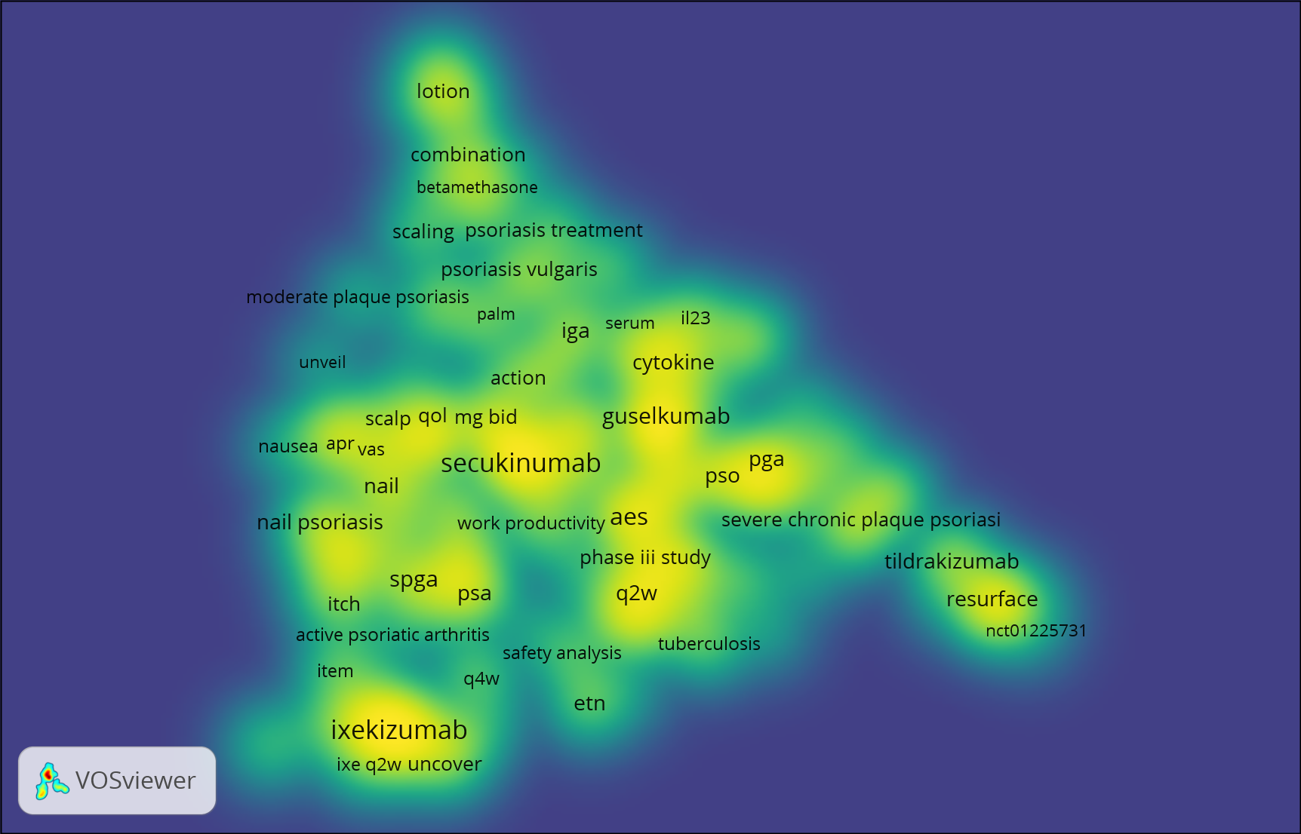
  - A matrix showing which existing psoriasis intervention reviews appeared in the top ten results of the 3 metrics considered (full text downloads, citations and Altmetric scores)

Review title | Combined download totals 2017 & 2018 | Highest citations 2017 or 2018 | Highest altmetric scores 2017 or 2018 | Total
Systemic pharmacological treatments for chronic plaque psoriasis: a network meta-analysis | X | X | X | 3
Topical treatments for scalp psoriasis |  | X |  | 1

  - Psoriasis - summary
Topic suggestions focus on psoriasis treatment. We currently have a highly-cited living network meta-analysis of systemic pharmacological treatments for chronic plaque psoriasis #156 which will continue through the next period.
Other areas highlighted, which are not covered by this review are:
Outcomes beyond the skin/comorbidities – effects of psoriasis treatments on non-skin outcomes. This might involve a collaboration with another Cochrane review group to ensure that appropriate ways of capturing non-skin outcomes were covered.
Update topical treatment review #66 (2013) for psoriasis.
A review focussed on adverse events of systemic treatments, including observational studies and long term outcomes and vulnerable populations including children, pregnancy and lactation
A focussed review of combination treatments with different biologics, or predictors of response using biomarkers i.e. stratified treatment trials – to help inform clinical practice decision-making.
A review of psychological and educational interventions for psoriasis – would these be materially different to psychological and educational interventions in other chronic conditions, and should this involve Cochrane groups/fields concerned with models for delivery of care?
Treatments for generalised pustular psoriasis using biologics

Urticaria
The number of DALYs 2017 for urticaria is 5,014,767, with a global prevalence of 1.13%.
  - Summary table
SR title suggestions from the survey | Current Cochrane Skin titles in this area | Research priorities
Chronic idiopathic urticaria  Clinically challenging  Clinician/healthcare professional  Interventions for antihistamine refractory chronic spontaneous urticaria  This is a condition of clinical importance for which new therapeutical agents became available in the last years. In addition, this title was already considered as Cochrane review, however the protocol was withdrawn from publication by CSG  Clinician/healthcare professional | #143 Interventions for chronic idiopathic urticaria excluding antihistamines (protocol 2014, withdrawn)  #45 Histamine H2-receptor antagonists for urticaria (2012)  #97 H1-antihistamines for chronic spontaneous urticaria (2014)
Angioedema
To envisage new disease markers or to improve the prevention methods
Researcher
  - New records of clinical trials published 2017-2019
The search of CENTRAL identified 194 references relevant to urticaria (including erythema and angioedema).
  - Urticaria – summary
Some new trials in this area. There are also 191 trial publications on pruritus, which may overlap.
Interventions for CSU excluding antihistamines – possibly an NMA?
Management of hereditary angioedema

Fungal infections of skin, nails and scalp
The number of DALYs 2017 for fungal skin infections is 4,154,505, with a global prevalence of 10.09%, the highest prevalence for skin diseases.
  - Summary table
SR title suggestions from the survey | Current Cochrane Skin titles in this area | Research priorities
Onychomycosis  They help to standardize decision making regarding patient's diagnosis and treatment  Clinician/healthcare professional & Researcher | #67 Oral antifungal medication for toenail onychomycosis (2017)
Interventions for Cutaneous Sporotrichosis: a targeted update of Cochrane review  Although potassium iodide, itraconazole and terbinafine are used in clinical medicine for the treatment of sporotrichosis, there is limited RCT evidence on their effectiveness and safety for sporotrichosis Clinician/healthcare professional | #71 Oral potassium iodide for the treatment of sporotrichosis (review published 2009; targeted update Interventions for cutaneous sporotrichosis 2017)
#49 Systemic antifungal therapy for tinea capitis in children (2016)
#140 Topical antifungal treatments for tinea cruris and tinea corporis (2014)
#01 Oral treatments for fungal infections of the skin of the foot (2012)
#04 Topical treatments for fungal infections of the skin and nails of the foot (2007) being updated as two titles:
#04 Topical and device-based treatments for fungal infections of the toenails (2020) & #147 Topical treatments for athlete's foot (protocol published 2013, title withdrawn)

  - New records of clinical trials published 2017-2019
The search of CENTRAL identified 59 references relevant to fungal skin diseases.
  - A matrix showing which existing fungal infection of the nails, skin and scalp intervention reviews appeared in the top ten results of the 3 metrics considered (full text downloads, citations and Altmetric scores)

Review title | Combined download totals 2017 & 2018 | Highest citations 2017 or 2018 | Highest altmetric scores 2017 or 2018 | Total
Oral antifungal medication for toenail onychomycosis |  | X | X | 2
Systemic antifungal therapy for tinea capitis in children |  | X |  | 1
Topical antifungal treatments for tinea cruris and tinea corporis | X |  |  | 1

  - Fungal infections of skin, nails and scalp – summary
Not many new trials in this area.
Update of #67 oral medication for toenail onychomycosis (2017)
Update of targeted update on cutaneous sporotrichosis (2009/2017)
#147 Topical treatments for athlete's foot

Viral infections of the skin
The number of DALYs 2017 for viral skin infections is 4,032,963, with a global prevalence of 1.77%.
  - Summary table
SR title suggestions from the survey | Current Cochrane Skin titles in this area | Research priorities
Interventions for prevention of herpes simplex labialis (cold sores on the lips)  Cold sore causes considerable burden of disease. How to prevent recurrence of cold sore is thus important.  Clinician/healthcare professional | #92 Interventions for prevention of herpes simplex labialis (cold sores on the lips) (2015)  #40 Interventions for treatment of herpes simplex labialis (cold sores on the lips) (protocol published 2011, team revived with new lead author 2016)
Topical treatments for cutaneous warts  High impact for individuals, Potential harm with incorrect treatment, Need for evidence for funders at all levels  Clinician/healthcare professional  Topical treatments for cutaneous warts  To be better able to advise patients what's best for this minor but often very bothersome problem in GP!  Clinician/healthcare professional & Researcher | #12 Topical treatments for cutaneous warts (2012)
#58 Interventions for cutaneous molluscum contagiosum (2017)
#89 Interventions for pityriasis rosea (2019)

  - New records of clinical trials published 2017-2019
The search of CENTRAL identified 87 references relevant to viral infections including viral warts, herpes simplex, herpes zoster, molluscum and pityriasis rosea.
  - Infectious diseases VOSViewer map
The VOSViewer text mining software identified the following intervention terms as appearing most frequently in the title and abstract text of the 87 references related to bacterial diseases (32), fungal skin diseases (59), leprosy (6), infectious diseases (87) and warts (39). The resulting map highlights cryotherapy for warts (see brightest yellow on the map below).
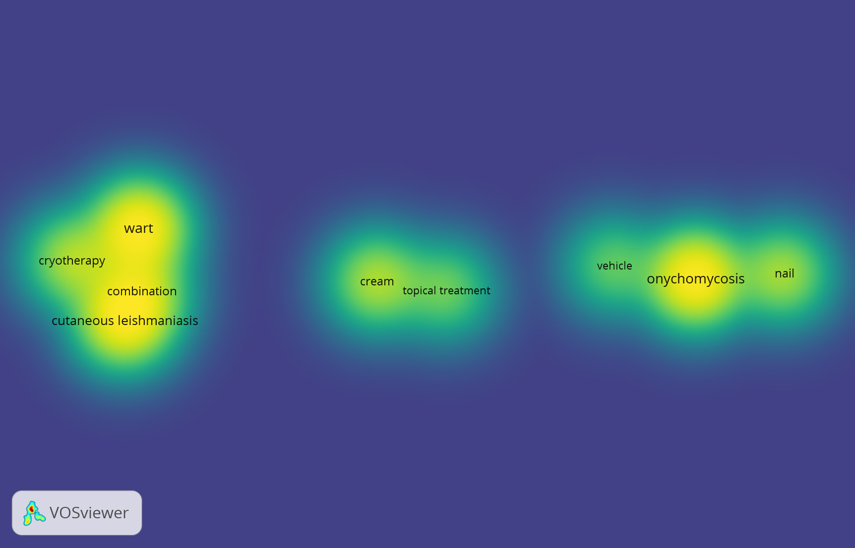
  - A matrix showing which existing viral infection intervention reviews appeared in the top ten results of the 3 metrics considered (full text downloads, citations and Altmetric scores)

Review title | Combined download totals 2017 & 2018 | Highest citations 2017 or 2018 | Highest altmetric scores 2017 or 2018 | Total
Interventions for cutaneous molluscum contagiosum |  | X | X | 2

  - Viral skin infections – summary
Not very many new trials in this area.
Update of #12 Topical treatments for cutaneous warts (2012)
Or update of #92 Interventions for prevention of herpes simplex labialis (cold sores on the lips) (2015)

Acne vulgaris
The number of DALYs 2017 for acne vulgaris is 2,547,620, with a global prevalence of 1.62%.
  - Summary table
SR title suggestions from the survey | Current Cochrane Skin titles in this area | Research priorities
Acne  They help to standardize decision making regarding patient's diagnosis and treatment  Clinician/healthcare professional & Researcher  Acne  Costly to treat  Clinician/healthcare professional  Overview of interventions for acne vulgaris  Plenty of systematic reviews were published focused on acne vulgaris, 52 systematic reviews were found in PubMED with "acne" and "systematic review" in title. We believe that there is sufficient studies to conduct the overview, which may provide the current overall evidence for interventions in treating acne Researcher |  | JLA top 10 priorities:  What management strategy should be adopted for the treatment of acne in order to optimise short and long-term outcomes?  How long do acne treatments take to work and which ones are fastest acting?  AAD clinical guideline gaps in research/knowledge:  Treatment of acne in persons of color  Treatment of acne in pregnant women
Inexpensive acne treatment  Because the tendency is to publish new and expensive treatments  Clinician/healthcare professional | #149 Topical benzoyl peroxide for acne (2020)  #155 Topical azelaic acid, salicylic acid, nicotinamide, sulphur, zinc and fruit acid (alpha-hydroxy acid) for acne (2020) | JLA top 10 priority: What is the best topical product for treating acne?  AAD clinical guideline gaps in research/knowledge:  - Efficacy, safety, and side effect profile of topical therapies in children 8-12 years of age  - Data on aspects of care that promote compliance in selected populations using topical therapy  - The incidence of cutaneous and systemic allergic response to topical therapies remains to be better quantified in the population  Physical modalities:  - Large, prospective, multicenter, randomized, double-blinded controlled trials comparing acne chemical peels to placebo  - Comparative effectiveness clinical trials for safety and efficacy of different peels
Oral isotretinoin for acne - Update  Oral isotretinoin remains the most effective acne treatment and we have concluded that there are still gaps and uncertainties on RCTs, especially regarding best oral isotretinoin doses/regimens in acne of all severities and serious adverse effects.  Clinician/healthcare professionals, researchers & guideline developer (4 authors of existing review)  Oral isotretinoin for acne  Prevalent disease  Researcher  Non-randomised studies of adverse effect data for isotretinoin  Title suggestion since last exercise | #33 Oral isotretinoin for acne (2019) | JLA top 10 priority: What is the correct way to use oral isotretinoin (Roaccutane) in acne in order to achieve the best outcomes with least risk of potentially serious adverse effects?  AAD clinical guideline gaps in research/knowledge:  - Long-term prospective studies to determine if there is a causal link between isotretinoin and depression  - Long-term prospective studies to determine if there is a causal link between isotretinoin and inflammatory bowel disease  - Studies of best methods for preventing isotretinoin-exposed pregnancies  - Prospective studies examining optimal total cumulative dosing based on type and severity of acne
New Oral Treatments for Acne Vulgaris
Due to the high impact on patients' quality of life, new oral treatments have significantly emerged over the last number of years. At the same time, quality of evidence is still remaining.
Clinician/healthcare professional & Researcher
Duration of oral antibiotics in management of acne  Important in these days on concern about antimicrobial resistance  Clinician/healthcare professional & Guideline developer (PCDS) |  | JLA top 10 priority: What is the correct way to use antibiotics in acne to achieve the best outcomes with least risk?  AAD clinical guideline gaps in research/knowledge:  Systemic antibiotics: Comparative studies on duration of oral antibiotics with and without topical treatment
Dietary interventions for acne  There are still uncertainties about the role of diet in acne pathogenesis and management  Clinician/healthcare professional; Guideline developer; Researcher  Complementary therapies for acne vulgaris  We published "Complementary therapies for acne vulgaris" in 2015, in which we did not make certain conclusion of the effectiveness of CAM therapies for acne. Through a quick search in relevant database, we found over hundred articles were published during the last 5 years concerned this topic. We may get certain conclusions based on even higher quality evidence for CAM therapies in treating acne.  Researcher |  | JLA top 10 priority: Which lifestyle factors affect acne susceptibility or acne severity the most and could diet be one of them?  AAD clinical guideline gaps in research/knowledge:  - Long-term, prospective, double-blind trials looking at the effect of low-glycemic index diet and milk (skim vs. whole) on acne  - Prospective studies of fish oil, probiotics, oral zinc, and topical tea tree oil
 | #122 Light therapies for acne (2016) | JLA top 10 priority: Which physical therapies, including lasers and other light based treatments, are safe and effective in treating acne?  AAD clinical guideline gaps in research/knowledge:  - Large, prospective, multicenter, randomized, double-blinded controlled trials comparing light and laser devices to placebo  - Comparative effectiveness clinical trials for safety and efficacy of different light and laser sources/wavelengths and which types of lesions they improve
JLA top 10 priority: What is the best way of managing acne in mature women who may/may not have underlying hormonal abnormalities?
AAD clinical guideline gaps in research/knowledge:
- Comparative studies on the duration of hormonal therapies with and without topical treatment
- Large, prospective studies to confirm the efficacy of spironolactone for the treatment of postadolescent acne in women
- Comparative effectiveness clinical trials of COCs in the treatment of acne
- Standardization of workup for patients with hormonal acne in whom PCOS is suspected
 |  | JLA top 10 priority: What is the best way of preventing acne?
 | #14 Interventions for acne scars (2016) | JLA top 10 priority: What is the best treatment for acne scars?
  - New records of clinical trials published 2017-2019
The search of CENTRAL identified 227 references relevant to acne.

  - Acne VOSViewer map
The VOSViewer text mining software identified the following intervention terms as appearing most frequently in the title and abstract text of the 227 references from the search: isotretinonin, combination therapy, benzoyl peroxide, adapalene, lotion (see brightest yellow on the map below).
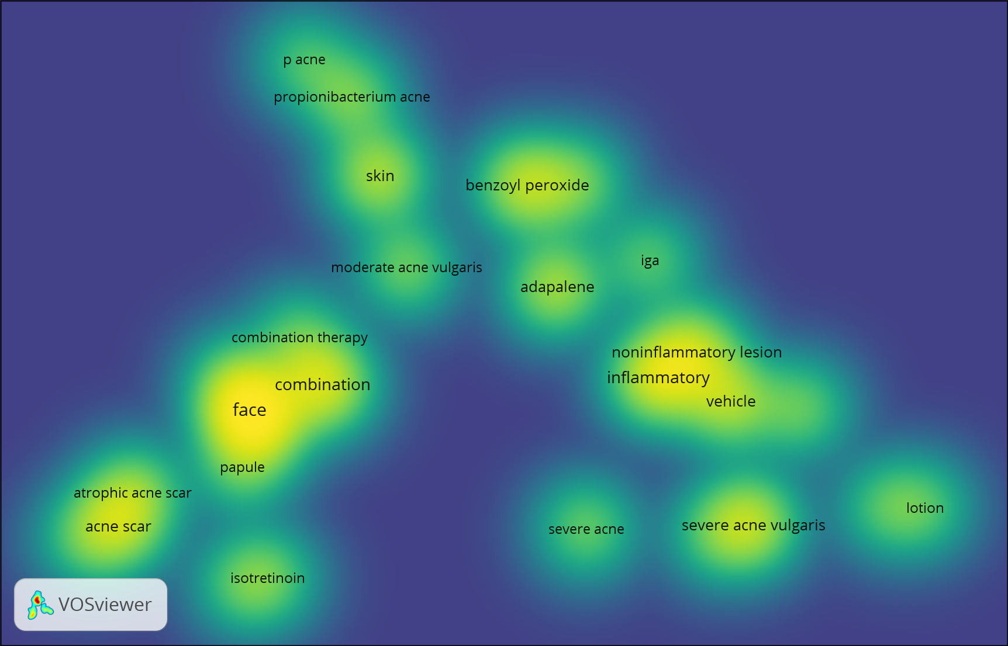

  - A matrix showing which existing psoriasis intervention reviews appeared in the top ten results of the 3 metrics considered (full text downloads, citations and Altmetric scores)
Review title | Combined download totals 2017 & 2018 | Highest citations 2017 or 2018 | Highest altmetric scores 2017 or 2018 | Total
Interventions for acne scars | X | X |  | 2
Light therapies for acne | X | X |  | 2
Complementary therapies for acne vulgaris | X |  |  | 1
Oral isotretinoin for acne |  |  | X | 1
Topical azelaic acid, salicylic acid, nicotinamide, sulphur, zinc and fruit acid for acne | X |  |  | 1

  - Acne vulgaris – summary
Significant new work in this area. Interventions for acne scars and light therapies for acne were both well-cited/downloaded although neither found good evidence for any intervention. These could be updated if there are good, new trials in these areas.
Other suggestions were:
NMA of treatments for acne, or an overview of existing systematic reviews of interventions
Update of isotretinoin for acne #33 (2019), including long-term safety (IBD, depression) potentially using non-randomised studies? The author team are keen to update this.
Duration of oral antibiotic treatment with/without topical treatment
Complementary therapies
Diet/nutritional supplements
Chemical peels, different chemical peels, oral contraceptive pill for treating acne
Focus on speed of onset of treatment
Focus on specific groups – children age 8-12, darker skin, pregnancy, older women

Bacterial infections of the skin (pyoderma and cellulitis)
The number of DALYs 2017 for bacterial skin infections is 2,274,455, with a global prevalence of 0.15%.
  - Summary table
SR title suggestions from the survey | Current Cochrane Skin titles in this area | Research priorities
Non-antimicrobial interventions for cellulitis/erysipelas  i. The last review which included non-antimicrobial interventions was published in 2010; ii. This is an under researched area and a review would summarise the present evidence and encourage research  Researcher | #56 Interventions for the treatment of cellulitis and erysipelas (2010)  #136 Interventions for the prevention of recurrent erysipelas and cellulitis (2017) | JLA top 10 priorities:  1. What are the best diagnostic criteria for cellulitis, and are they different for different patient groups (e.g. people with lymphoedema)?  2. How can healthcare professionals be best supported to accurately diagnose and manage cellulitis and to advise their patients in how to prevent relapses?* (*This topic includes the development of tests or tools to assist with the diagnosis and management of cellulitis)  3. What are the early signs and symptoms of cellulitis that can help to ensure speedy treatment?  4. When treating cellulitis, could a higher initial dose and / or longer course of antibiotics result in a quicker recovery and / or fewer relapses?  5. Is the duration, dose and method of administration of antibiotics needed to treat cellulitis related to patient characteristics (e.g. patients with diabetes, who are overweight or have swelling of the limb may require a higher dose/duration)?  6. Does rest / elevation during an episode of cellulitis help to speed up recovery and improve symptoms, compared to exercise/movement of the affected limb?  7. Is there a role for the use of compression garments / bandages on the affected limb during an episode (when tolerable), or immediately following an episode of cellulitis, to speed recovery and reduce complications and recurrence?  8. What is the best NON-antibiotic intervention for the prevention of cellulitis (e.g. skin care, foot care, moisturisers, antiseptics, life-style changes such as weight-loss and exercise, compression garments, treating athlete’s foot, complementary and alternative therapy)?  9. What type of patients are most likely to benefit from low-dose antibiotics to prevent repeated episodes of cellulitis?  10. How safe are long-term antibiotics for the prevention of recurrent cellulitis?
Management of scalp folliculitis  Optimal primary care management of a long term condition unclear/ not widely known  Clinician/healthcare professional & Guideline developer (PCDS) | #173 Interventions for bacterial folliculitis and boils (furuncles and carbuncles) (prioritised 2017, review submitted)
Interventions for pyoderma gangrenosum
They reflect issues and questions that I have regularly in my clinical practice
Clinician/healthcare professional
Pyoderma gangrenosum
Best evidence of treatment
Clinician/healthcare professional & Researcher

  - New records of clinical trials published 2017-2019
The search of CENTRAL identified 32 references relevant to bacterial diseases including pyoderma, cellulitis, impetigo, boils and folliculitis.
  - A matrix showing which existing pyoderma and cellulitis intervention reviews appeared in the top ten results of the 3 metrics considered (full text downloads, citations and Altmetric scores)

Review title | Combined download totals 2017 & 2018 | Highest citations 2017 or 2018 | Highest altmetric scores 2017 or 2018 | Total
Interventions for the prevention of recurrent erysipelas and cellulitis |  |  | X | 1

  - Bacterial skin infections – summary
Very little new work in this area. Suggestions include:
Interventions for pyoderma gangrenosum
Management of scalp folliculitis
Non-antimicrobial interventions for cellulitis/erysipelas

Contact Dermatitis
The number of DALYs 2017 for contact dermatitis is 1,989,159, with a global prevalence of 1.08%.
  - Summary table
SR title suggestions from the survey | Current Cochrane Skin titles in this area | Research priorities
No suggestions | #28 Interventions for preventing occupational irritant hand dermatitis (2018)
  - New records of clinical trials published 2017-2019
The search of CENTRAL identified 25 references relevant to contact dermatitis.
  - A matrix showing which existing contact dermatitis intervention reviews appeared in the top ten results of the 3 metrics considered (full text downloads, citations and Altmetric scores)

Review title | Combined download totals 2017 & 2018 | Highest citations 2017 or 2018 | Highest altmetric scores 2017 or 2018 | Total
Interventions for preventing occupational irritant hand dermatitis |  |  | X | 1

  - Contact dermatitis – summary
Very little new work in this area and no suggestions received.

Skin Cancer
  - Malignant skin melanoma
The number of DALYs 2017 for malignant skin melanoma is 1,654,120, with a global prevalence of 0.03%.
  - Non-melanoma skin cancer
The number of DALYs 2017 for non-melanoma skin cancer is 1,329,250 (99.8% cutaneous squamous-cell carcinoma, 0.2% basal-cell carcinoma), with a global prevalence of 0.03%.
  - Summary table
SR title suggestions from the survey | Current Cochrane Skin titles in this area | Research priorities
Melanoma  Guideline developer (AAD)  Interventions for melanoma  An interesting review.  Patient/Consumer  Melanoma  They help to standardize decision making regarding patient's diagnosis and treatment  Clinician/healthcare professional & Researcher | #03 Systemic treatments for metastatic cutaneous melanoma (2018)  #126 Sentinel lymph node biopsy followed by lymph node dissection for localised primary cutaneous melanoma (2015)  #62 Interferon alpha for the adjuvant treatment of cutaneous melanoma (2013)  #171 Neoadjuvant treatment for malignant and metastatic cutaneous melanoma (protocol 2018) | NICE research recommendations:  In people with stage I–III melanoma does vitamin D supplementation improve overall survival?  In people diagnosed with melanoma what is the effect of drug therapy to treat concurrent conditions on disease‑specific survival?
Surgical excision margins for primary cutaneous melanoma  i. Review last completed >5-10 years ago; ii. The prevalence of skin cancer is increasing and makes up >30% of outpatient work  Clinician/healthcare professional  Surgical incision margins for primary cutaneous melanoma  It is important to cause the least damage to the skin whilst being sure that sufficient area is removed to prevent subsequent recurrence of the problem  Patient/Consumer | #35 Surgical excision margins for primary cutaneous melanoma (2009)  #177 The efficacy of different surgical excision methods for skin cancer involving the nail unit (protocol underway) | AAD guidelines gaps in research: the need for further study regarding Mohs micrographic surgery and other exhaustive margin control techniques for both invasive and in situ cutaneous melanoma.
Stereotactic radiotherapy and immune checkpoint inhibitors (anti PD‐1 or anti PD‐L1) versus immune checkpoint inhibitors (anti PD‐1 or anti PD‐L1) alone for melanoma  Some studies have reported that combined with stereotactic radiotherapy and immune checkpoint inhibitors in the treatment of several solid tumors, including in unirradiated tumors, the proportion of tumor regression is significantly higher than the use of these treatments alone. However, no systematic review has focused on this topic.  Researcher | #03 Systemic treatments for metastatic cutaneous melanoma (2018)
Interventions for Basal Cell Carcinoma (update)  i. Recent management advances (targeted molecular therapies) suggest an update to the 2007 guidance may be beneficial and as the most common malignancy worldwide a review in this area has the potential to greatly impact public health.  Guideline developer (AAD)  Interventions for basal cell carcinoma  i. Review last completed >5-10 years ago; ii. The prevalence of skin cancer is increasing and makes up >30% of outpatient work; iii. New skin cancer drugs (e.g. hedgehog inhibitors) have become available  Clinician/healthcare professional  Living NMA review of treatments for BCC  Because the field is changing quickly  Researcher | #26 Interventions for basal cell carcinoma of the skin (2007, update underway, due 2020) | AAD guidelines gaps in research: the clinical and prognostic value of biomarkers that may aid in the identification of tumors susceptible to targeted systemic therapy. Although the treatment of localized tumors is usually successful, significant gaps in research have been identified with regard to the identification of noninvasive treatment modalities with recurrence rates comparable to those with surgery. Moreover, much remains to be learned about the optimal use of currently available systemic inhibitors of the hedgehog pathway, as well as the identification of novel therapies that are able to achieve high response rates with a more tolerable side effect profile.
Non-Melanoma Skin Cancer (Bcc/cSCC)  Guideline developer (AAD)  Interventions for Squamous Cell Carcinoma (update)  Recent management advances (immunotherapy, target therapies) suggest an update to the 2010 review may be warranted and has the potential to impact management of a condition with poor prognosis due to potential recurrence and metastatic tendency.  Guideline developer (AAD)  Intervention for non-metastatic squamous cell cancer of the skin  Squamous cell cancer can be very worrying and often unsightly.  Patient/Consumer | #74 Interventions for non-metastatic squamous cell carcinoma of the skin (2010) | AAD guidelines gaps in research: The relative importance of risk factors for cSCC, including the impact of immunosuppression over time, requires further elucidation. The role of SLNB in high-risk cSCC is unclear, and additional studies are warranted to determine their utility and indications. Novel therapeutic modalities are expected to continue to emerge. Results of ongoing clinical trials with immune checkpoint inhibitors for locally advanced and metastatic cSCC are expected in near future.
Interventions for preventing non‐melanoma skin cancers in high‐risk groups  Prevention should be prioritised alongside diagnosis and treatment  Clinician/healthcare professional | #39 Interventions for preventing non-melanoma skin cancers in high-risk groups (2007)  Partial update: #160 Interventions for preventing keratinocyte cancer in high-risk groups not receiving immunosuppressive therapy (protocol 2016)
Interventions for cutaneous Bowen's disease and/or AK  i. Review last completed >5-10 years ago; ii. The prevalence of skin cancer is increasing and makes up >30% of outpatient work; iii. New skin cancer drugs (e.g. hedgehog inhibitors) have become available  Clinician/healthcare professional | #107 Interventions for cutaneous Bowen's disease (2013)  #34 Interventions for actinic keratoses (2012) (update by way of a new protocol ‘Topical treatments for actinic keratosis of the head and neck’ 2019)
 | #86 Interventions for melanoma in situ, including lentigo maligna (2014) | NICE research recommendations:  - In people with reported atypical spitzoid lesions, how effective are fluorescence in‑situ hybridization (FISH), comparative genomic hybridization (CGH) and tests to detect driver mutations compared with histopathological examination alone in predicting disease‑specific survival  - For people with lentigo maligna (stage 0 in sun‑damaged skin, usually on the face) how effective is Mohs micrographic surgery, compared with excision with a 0.5 cm clinical margin, in preventing biopsy‑proven local recurrence at 5 years.  AAD guidelines gaps in research: lack of RCTs for the surgical and nonsurgical treatment of melanoma in situ, lentigo maligna type.
Treatments for rare skin cancers
They reflect issues and questions that I have regularly in my clinical practice
Clinician/healthcare professional
Visual inspection for diagnosing cutaneous melanoma in adults  Still the best form of diagnosing cutaneous melanoma when the practitioner has been taught the necessary skills.  Patient/Consumer  Dermoscopy for non-melanoma  They reflect issues and questions that I have regularly in my clinical practice  Clinician/healthcare professional  Exfoliate cytology for diagnosing basal cell carcinoma and other skin cancers in adults.  Exfoliation should provide adequate determination of the presence of skin cancer  Patient/Consumer | Special Collection: Diagnosing skin cancer (2018)  #169 Ultrasound, CT, MRI, or PET-CT for staging and re-staging of adults with cutaneous melanoma (2019)  #170 Sentinel lymph node biopsy for staging cutaneous melanoma and cutaneous squamous cell carcinoma in adults (final DTA review due 2020) | AAD guidelines gaps in research: the use and value of dermoscopy and other imaging modalities in the diagnosis of BCC.
Skin Cancer Screening, counseling and prevention  Guideline developer (AAD)  Skin cancer screening  Frequency of consultation at general practise  Clinician/healthcare professional  PET-CT surveillance in melanoma  Title suggestions by email since last exercise  Skin cancer prevention in Latin America  We have high exposures and a very high UV Index  South American Satellite | #166 Screening for reducing morbidity and mortality in malignant melanoma (2019)  #52 Educational programmes for skin cancer prevention (protocol 2014 but not continued)  #157 Sun protection for preventing basal cell and squamous cell skin cancers (2016) | NICE research recommendation:  In people treated for high‑risk stage II and III melanoma, does regular surveillance imaging improve melanoma‑specific survival compared with routine clinical follow‑up alone?  AAD guidelines gaps in research: In the context of prevention, the long-term utility of sun protection and avoidance measures remains to be clarified.

  - New records of clinical trials published 2017-2019
The search of CENTRAL identified 1074 references relevant to skin cancer (includes actinic keratosis (94), NMSC (276), malignant melanoma (583), Kaposi sarcoma (6), mycosis fungoides etc (56), skin cancer screening etc (66), lentigo maligna (3), merkel cell (10). Some records appear in two folders, hence discrepancies in totals).

  - Skin cancer VOSViewer map
The VOSViewer text mining software identified the following intervention terms as appearing most frequently in the title and abstract text of the 1074 references from the search: nivolumab, ipilimumab, adjuvant therapy near metastatic melanoma, ingenol mebutate near actinic keratosis (see brightest yellow on the map below).
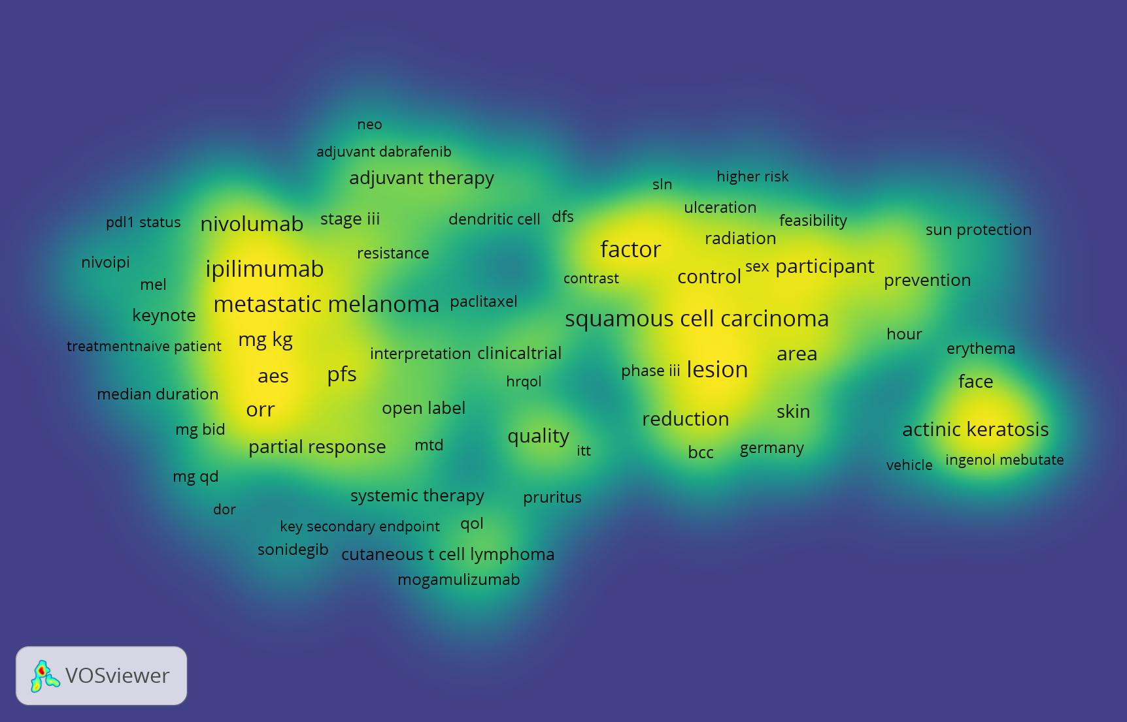
  - A matrix showing which existing skin cancer intervention reviews appeared in the top ten results of the 3 metrics considered (full text downloads, citations and Altmetric scores)

Review title | Combined download totals 2017 & 2018 | Highest citations 2017 or 2018 | Highest altmetric scores 2017 or 2018 | Total
Sentinel lymph node biopsy followed by lymph node dissection for localised primary cutaneous melanoma |  | X |  | 1
Systemic treatments for metastatic cutaneous melanoma |  |  | X | 1

  - Skin cancer – summary
Huge number of new trials in this area, especially in malignant melanoma.
Suggestions include:
Melanoma:
Surgical incision margins for primary cutaneous melanoma – update #35 (2009)
Update of #03 NMA of systemic treatments for metastatic cutaneous melanoma – focused on inhibitors of hedgehog pathway; focused on stereotactic radiotherapy
NMSC:
Update of #74 Interventions for non-metastatic squamous cell carcinoma of the skin (2010) due to new immunotherapy or targeted therapies
Update of #39 Interventions for preventing non-melanoma skin cancers in high-risk groups (2007)
Update of #107 Interventions for cutaneous Bowen's disease (2013)
Targeted update of diagnostic test accuracy reviews e.g. Exfoliate cytology for diagnosing basal cell carcinoma and other skin cancers in adults (2018).
Update of #157 Sun protection for preventing basal cell and squamous cell skin cancers (2016)

Pruritus
The number of DALYs 2017 for pruritus is 755,573, with a global prevalence of 0.97%.
  - Summary table
SR title suggestions from the survey | Current Cochrane Skin titles in this area | Research priorities
No suggestions | #176 Interventions for chronic pruritus of unknown origin (prioritised 2017, published 2020)

  - New records of clinical trials published 2017-2019
The search of CENTRAL identified 191 references relevant to pruritus and itch.
  - Pruritus – summary
Significant number of new trials. Likely many are covered by urticaria and eczema. No new suggestions.

Alopecia areata
The number of DALYs 2017 for alopecia areata is 523,059, with a global prevalence of 0.22%.
  - Summary table
SR title suggestions from the survey | Current Cochrane Skin titles in this area | JLA research priorities
Alopecia areata  The pharmaceutical industry is undertaking large phase III trials, the literature is evolving  Clinical society, association or professional organisation (British Association of Dermatologists' Therapy & Guidelines sub-committee)  Alopecia areata  Unmet need, no effective therapy, common and social problem  Clinical society, association or professional organisation  Alopecia areata  What can we recommend?  Clinician/healthcare professional & Researcher  Update to treaments/interventions for alopecia areata  Last review of interventions was 2008, also identified as a priority by the hair loss PSP  Patient group or consumer group | #30 Interventions for alopecia areata (prioritised 2017, protocol Treatments for alopecia areata: a network meta-analysis due 2020) | What are the causes of alopecia areata? For example - medications, medical problems, lifestyle, vaccinations.  Are immunosuppressant therapies (for example- methotrexate, mycophenolate mofetil) better than placebo in the treatment of alopecia areata?  In alopecia areata, are biological therapies (including JAK inhibitors and anti-cytokine therapies) more effective than placebo in causing hair re-growth?  Can progression of alopecia areata be prevented by early diagnosis and treatment?  Do any treatments have a long-term benefit in alopecia areata?  What can be learnt about alopecia areata from other autoimmune conditions?  In whom does alopecia areata hair loss progress and why?  How effective are alternative therapies in alopecia areata?
Use of Oral Minoxidil  There is a high number of dermatologists prescribing Oral Minoxidil for different types of alopecia; however, there is a few limited literature assessing its effect and effectiveness.  Clinician/healthcare professional & Researcher | #30 Interventions for alopecia areata (prioritised 2017, protocol Treatments for alopecia areata: a network meta-analysis due 2020)
Use of Laser Therapy for Alopecia  What is the current quality of evidence of Laser Therapy for Alopecia.  Clinician/healthcare professional & Researcher | #30 Interventions for alopecia areata (prioritised 2017, protocol Treatments for alopecia areata: a network meta-analysis due 2020)
Alopecia universalis  To keep us up to date and give us some hope  Patient/Consumer | #30 Interventions for alopecia areata (prioritised 2017, protocol Treatments for alopecia areata: a network meta-analysis due 2020)
Non-surgical interventions for androgenetic Alopecia in men  Androgenetic Alopecia is a common disorder, affecting about 70% of Caucasian men around 70 year old, reflecting an important area of interest in dermatology routine, and there are no systematic reviews about it, which are the best evidence in the literature  Title suggestion by email since last exercise | #48 Non-surgical interventions for androgenic alopecia in men (never published)
Diffuse hair loss in female patients  Clear best practice guidelines yet to be formulated  Clinician/healthcare professional | #123 Interventions for female pattern hair loss (2016) | What are the causes of female pattern hair loss? For example, genetic, hormonal and childbirth, autoimmune, dietary, other medical conditions, environmental factors.  Is spironolactone helpful in managing female pattern hair loss?  In female pattern hair loss, does hormone replacement therapy (HRT) halt progression of the hair loss compared to placebo?
Review of Treatment for frontal fibrosing alopecia  Identified as a top priority by the hair loss PSP  Patient group or consumer group |  | What is the most effective treatment for frontal fibrosing alopecia?  What are the causes of frontal fibrosing alopecia?- for example- dietary, genetic, autoimmune, skin care products, medications, hormonal, environmental, vaccination, infection.
Review of dietary interventions for hair loss  Identified as a priority by the hair loss PSP  Patient group or consumer group |  | Do certain foods, vitamins or nutritional supplements improve hair re-growth in alopecia areata?
Review of psychological interventions for hair loss disorders  Identified as a priority by the hair loss PSP  Patient group or consumer group |  | Are psychological interventions helpful in alopecia areata?
Autologous platelet-rich plasma therapy for pattern hair loss  Title suggestion by email since last exercise | #30 Interventions for alopecia areata (prioritised 2017, protocol Treatments for alopecia areata: a network meta-analysis due 2020)
Review of treatment of Lichen planopilaris  Identified as a priority by the hair loss PSP  Patient group or consumer group |  | What is the most effective treatment for Lichen planopilaris?
JLA research priorities for other hair loss disorders
- In all types of hair loss, are psychological therapies effective in improving patient outcomes?
- In all types of hair loss, what outcome measures should be used to assess severity of hair loss, progression and impact on the individual?
- In all types of hair loss, does raising ferritin levels/replacing iron improve hair growth? And what is the optimal level of ferritin?
- In all types of hair loss, do certain diets or nutritional supplements (for example vitamin D) prevent or improve hair loss?

  - New records of clinical trials published 2017-2019
The search of CENTRAL identified 116 references relevant to alopecia, telogen and lichen planopilaris.

  - A matrix showing which existing alopecia intervention reviews appeared in the top ten results of the 3 metrics considered (full text downloads, citations and Altmetric scores)

Review title | Combined download totals 2017 & 2018 | Highest citations 2017 or 2018 | Highest altmetric scores 2017 or 2018 | Total
Interventions for female pattern hair loss | X | X |  | 2

  - Alopecia areata – summary
Significant number of new trial publications. Several suggestions are already captured by the ongoing review #30 ‘Treatments for alopecia areata: a network meta-analysis’, which was prioritised in the last round. Other suggestions are:
Reactivation of #48 Non-surgical interventions for androgenic alopecia in men (never published)
Update of #123 Interventions for female pattern hair loss (2016), including focus on spironolactone
Interventions for frontal fibrosing alopecia
Dietary or psychological interventions for hair loss disorders
Autologous platelet-rich plasma therapy for pattern hair loss
Interventions for lichen planopilaris

Cutaneous and mucocutaneous leishmaniasis
The number of DALYs 2017 for cutaneous and mucocutaneous leishmaniasis is 263,646, with a global prevalence of 0.06%.
  - Summary table
SR title suggestions from the survey | Current Cochrane Skin titles in this area | Research priorities
Interventions for cutaneous leishmaniasis (both Old world and American))  Clinician/healthcare professional & Researcher | #85 Interventions for Old World cutaneous leishmaniasis (2017)  #65 Interventions for American cutaneous and mucocutaneous leishmaniasis (update due 2020) | Cutaneous leishmaniasis is one of the WHO’s Skin Neglected tropical diseases.

  - New records of clinical trials published 2017-2019
The search of CENTRAL identified 11 references relevant to leishmaniasis.

  - Infectious diseases (including leishmaniasis records) VOSViewer map
The VOSViewer text mining software map for infectious diseases includes the leishmaniasis records. The map highlights combination therapy for leishmaniasis (see brightest yellow on the map below).

  - A matrix showing which existing leishmaniasis intervention reviews appeared in the top ten results of the 3 metrics considered (full text downloads, citations and Altmetric scores)

Review title | Combined download totals 2017 & 2018 | Highest citations 2017 or 2018 | Highest altmetric scores 2017 or 2018 | Total
Interventions for Old World cutaneous leishmaniasis |  |  | X | 1

  - Cutaneous leishmaniasis – summary
Some new publications. Consider update of #85 Interventions for Old World cutaneous leishmaniasis (2017).

Seborrhoeic dermatitis
The number of DALYs 2017 for seborrhoeic dermatitis is 135,606, with a global prevalence of 0.14%.
  - Summary table
SR title suggestions from the survey | Current Cochrane Skin titles in this area | Research priorities
No suggestions | #139 Topical anti-inflammatory agents for seborrhoeic dermatitis of the face or scalp (2014)  #120 Topical antifungals for seborrhoeic dermatitis (2015)  #153 Interventions for infantile seborrhoeic dermatitis (including cradle cap) (2019)
  - New records of clinical trials published 2017-2019
The search of CENTRAL identified 6 references relevant to seborrhoeic dermatitis.

Leprosy
The number of DALYs 2017 for leprosy is 31,513, with a global prevalence of 0.01%.
  - Summary table
SR title suggestions from the survey | Current Cochrane Skin titles in this area | Research priorities
No suggestions | #60 Interventions for ulceration and other skin changes caused by nerve damage in leprosy (2019)  #100 Interventions for erythema nodosum leprosum (2009) | Leprosy is one of the WHO’s Skin Neglected tropical diseases.
  - New records of clinical trials published 2017-2019
The search of CENTRAL identified 6 references relevant to leprosy.

Other skin and subcutaneous diseases (includes e.g. bullous diseases, connective tissue diseases, and cutaneous drug reactions)
The number of DALYs 2017 for other skin and subcutaneous diseases is 3,107,688, with a global prevalence of 7.47%.
Note this data does not include Cutaneous T Cell Lymphoma, classified by the WHO under Neoplasms of haematopoietic or lymphoid tissues.

  - Summary table
SR title suggestions from the survey | Current Cochrane Skin titles in this area | Research priorities
Interventions for pemphigus (update)  Evidence of the efficacy of treatments not involving corticosteriods is increasing suggesting a review of interventions could inform management strategies.  Guideline developer (AAD)  Pemphigus Treatment  Evidence on non-steroid treatments  Clinician/healthcare professional, Guideline developer & Researcher  Interventions for pemphigus  South American Satellite  Bullous Pemphigoid Treatment  Evidence on non-steroid treatments  Clinician/healthcare professional, Guideline developer & Researcher  Bullous diseases  To reduce or replace the long-term use of steroids that cause severe side effects  Clinical society, association or professional organisation  Blistering disorders  Clear best practice guidelines yet to be formulated  Clinician/healthcare professional  Herpetiforme dermatitis  To update the review methodology regarding meta-analytical data  Researcher  Dermatologic manifestations of Celiac disease  Misdiagnosis and consequent mistreatment  Clinician/healthcare professional | #106 Interventions for pemphigus vulgaris and pemphigus foliaceus (2009)  #18 Interventions for bullous pemphigoid (2010)  #22 Interventions for mucous membrane pemphigoid and epidermolysis bullosa acquisita (2006, stable) | (CEBD undertaking a JLA PSP: Treatment of Pemphigus and Pemphigoid Priority Setting partnership)
Interventions for Cutaneous T Cell Lymphoma  As appropriate treatment of cutaneous T cell lymphoma requires assessment of many factors, a review of available interventions- both skin-directed and systemic- can provide essential data for informing the decision-making process.  Guideline developer (AAD)  Interventions for mycosis fungoides  Mycosis fungoides is a neglected disease  Clinician/healthcare professional  Interventions for mycosis fungoides  i. High impact for individuals, ii. Potential harm with incorrect treatment, iii. Need for evidence for funders at all levels  Clinician/healthcare professional  Mycosis Fungoides  Evidence on new skin directed therapies  Clinician/healthcare professional, Guideline developer & Researcher  Skin lymphomas  They help to standardize decision making regarding patient's diagnosis and treatment  Clinician/healthcare professional & Researcher  Lymphomatoid Papulosis  Evidence on new therapies  Clinician/healthcare professional, Guideline developer & Researcher | #129 Interventions for mycosis fungoides (2012, update underway due 2020)
Hidradenitis suppurativa  i.The pharmaceutical industry is undertaking large phase III trials, ii.The literature is evolving  Clinical society, association or professional organisation (British Association of Dermatologists' Therapy & Guidelines sub-committee)  Management of Hidradenitis Suppurativa  Optimal primary care management of a long term condition unclear/ not widely known  Clinician/healthcare professional & Guideline developer (PCDS)  Interventions for hidradenitis suppurativa  i. High impact for individuals, ii. Potential harm with incorrect treatment, iii. Need for evidence for funders at all levels  Clinician/healthcare professional | #81 Interventions for hidradenitis suppurativa (2015) | JLA top 10 priorities:  1. What is the most effective and safe group of oral treatments in treating HS (e.g. antibiotics, hormonal treatments, retinoids, immunosuppressants, metformin, steroids)?  2. What is the best management of an acute flare?  3. What is the impact of HS and its treatment on people with HS (physical, psychological, financial, social, quality of life)?  4. How effective are biologics (etanercept, adalimumab, infliximab, ustekinumab) in treating HS?  5. Does early diagnosis and aggressive treatment influence the course of HS?  6. What is the best surgical procedure to perform in treating HS, e.g. incision and drainage, local excision, wide excision?  7. Which factors are useful in determining the prognosis (disease progression) of HS?  8. What is the best method of wound care after surgery or for active disease (e.g. skin grafts, secondary intention, dressings)?  9. To what extent is HS caused by genetic factors?  10. What is the best management of pain associated with HS?
Vitiligo  i. The pharmaceutical industry is undertaking large phase III trials, ii. The literature is evolving  Clinical society, association or professional organisation (British Association of Dermatologists' Therapy & Guidelines sub-committee)  Management of vitiligo  TCIs widely used by dermatologists and GPwERs but CCG pharmacists are very concerned about GPs prescribing them  Clinician/healthcare professional & Guideline developer (PCDS)  Vitiligo  Unmet need, no effective therapy, common and social problem  Clinical society, association or professional organisation | #24 Interventions for vitiligo (2015) | JLA top 10 priorities:  1. How effective are systemic immunosuppressants in treating vitiligo?  2. How much do psychological interventions help people with vitiligo?  3. Which treatment is more effective for vitiligo: light therapy or calcineurin inhibitors?  4. How effective is ultraviolet B therapy when combined with creams or ointments in treating vitiligo?  5. What role might gene therapy play in the treatment of vitiligo?  6. How effective are hormones or hormone-related substances that stimulate pigment cells (melanocyte-stimulating hormone analogues, afamelanotide) in treating vitiligo?  7. Which treatment is more effective for vitiligo: calcineurin inhibitors or steroid creams⁄ ointments?  8. Which treatment is more effective for vitiligo: steroid creams ⁄ointments or light therapy?  9. How effective is the addition of psychological interventions to patients using cosmetic camouflage for improving their quality of life?  10. How effective is pseudocatalase cream (combined with brief exposure to ultraviolet B) in treating vitiligo?
Interventions for hyperhidrosis  Current review about interventions for excessive sweating has been withdrawn  Researcher  Quality of life and hyperhidrosis  Very under-represented condition considering its prevalence  Researcher | #20 Interventions for excessive sweating of unknown cause (protocol 2011, review never published) | JLA Top 10 priorities:  1. Are there any safe and effective permanent solutions for hyperhidrosis?  2. What is the most effective and safe oral treatment (drugs taken by mouth) for hyperhidrosis?  3. What are the most effective and safe ways to reduce sweating in particular areas of the body (e.g. hands, feet, underarms, face, head etc.)?  4. How does hyperhidrosis affect quality of life?  5. Are combinations of different treatments more effective than one type of treatment for hyperhidrosis?  6. What is the most safe and effective treatment for mild to moderate hyperhidrosis?  7. Could targeted therapies or biologics (e.g. antibodies, hormones, stem cells), be effective in treating hyperhidrosis?  8. What is the most effective severity scale that can be used to determine if a person is eligible for hyperhidrosis treatment?  9. What is the safest and most effective surgery for hyperhidrosis?  10. How safe are hyperhidrosis treatments at different stages of life, e.g. childhood, pregnancy and breastfeeding?
Topical interventions for genital lichen sclerosus  #4 PSP knowledge gap in lichen sclerosus: 'Are there effective topical treatments other than topical steroids in the treatment of lichen sclerosus?'  Clinician/healthcare professional  Genital lichen sclerosus  There is a need to improve treatment for many patients  Clinician/healthcare professional & Researcher | #108 Topical interventions for genital lichen sclerosus (2011) | JLA Top 10 priorities:  1. What is the best way to prevent and manage anatomical changes caused by lichen sclerosus? [Anatomical changes includes fusion, altered shape of the genitals and scarring.]  2. What is the best way to diagnose lichen sclerosus (diagnostic criteria)? [Diagnostic criteria may include assessing clinical features (visible signs), taking a biopsy (skin sample) or doing tests (e.g. blood tests). The criteria may also include indicators of disease severity. Necessity of biopsy and adverse effects from biopsy may also be investigated.]  3. What surgical treatments should be offered for lichen sclerosus? [Surgical treatments include (but are not limited to) laser, platelet-rich plasma or lipofilling (fat transfer). These treatments can be used in the management of scarring, anatomical changes or symptoms associated with lichen sclerosus. When should surgical treatments be offered and what are the long-term outcomes?]  4. Are there effective topical treatments other than topical steroids in the treatment of lichen sclerosus? [This includes what should be done when topical steroids fail. 'Other topical treatments' may include (but are not limited to) topical calcineurin inhibitors such as tacrolimus and pimecrolimus.]  5. What is the risk of developing cancer in patients with lichen sclerosus? [This includes being able to identify those at greatest risk and whether certain treatments increase or lower/reduce the risk of cancer.]  6. Which aspects of lichen sclerosus should be measured to assess response to treatment?  7. Can lichen sclerosus be prevented from occurring and what are the trigger factors? [Trigger factors include both factors responsible for development of lichen sclerosus and for its flare ups. These may include (but are not limited to) irritation from clothing/chemicals/urine, trauma, environmental factors, drugs and medications.]  8. Is it necessary to continue treatment for patients with lichen sclerosus who do not have any symptoms and/or signs of disease activity? [Patients without symptoms includes those who are in remission after treatment, as well as those who have asymptomatic disease. This includes follow up arrangements such as frequency (how often), duration (how long) and by whom (which health professional)?]  9. What is the impact on quality of life? [Quality of life includes effect of day to day living, psychological health and sexual relationships. This includes how psychological or social support can be best used to help people with lichen sclerosus.]  10. Does the disease course of lichen sclerosus differ in boys and girls, adult males and females? [This includes whether lichen sclerosus can remit completely.]
Stevens Johnson/Toxic epidermal necrolysis  Potentially lethal diseases with no effective treatment  Clinical society, association or professional organisation  Toxic epidermal necrosis  Uncommon but very serious condition  Clinician/healthcare professional & Researcher  Interventions for toxic epidermal necrolysis  i. High impact for individuals, ii. Potential harm with incorrect treatment, iii. Need for evidence for funders at all levels  Clinician/healthcare professional  Interventions for severe drug reactions  South American Satellite  Drug rash  Lack of evidence  Clinician/healthcare professional  Chemically induced Urticaria  To establish diagnosis and treatment  Researcher  Erythema multiforme  It would be of importance to look at evidence of treatment  Clinician/healthcare professional & Researcher | #07 Interventions for toxic epidermal necrolysis (2002)  Prioritised 2017, Systemic interventions for treatment of Stevens-Johnson syndrome (SJS), toxic epidermal necrolysis (TEN), and SJS/TEN overlap syndrome, protocol 2018
IPD Meta-analysis of Adverse Reaction Outcomes in Allergic and Healthy Patients Exposed to Food-containing the Yellow Colorant Tartrazine and Similar Compounds
Title suggestions by email since last exercise
Interventions for the management of radio/chemotherapy induced dermatitis of the head and neck
Title suggestions by email since last exercise
Melasma  South American Satellite | #23 Interventions for melasma (2010)
Topical Treatment for Neurodermatitis (lichen simplex chronicus)
Title suggestions by email since last exercise
Acne rosacea  Aesthetic and annoying problem for a high number of patients  Clinical society, association or professional organisation | #25 Interventions for rosacea (2015)
Photodermatoses  South American Satellite  Usefulness of sunscreens to diminish morbimortality  Because is difficult to recommend what to do with such an expensive practice.  Clinician/healthcare professional | #64 Interventions for polymorphic light eruption (protocol 2005, review never published)
Epidermolysis Bullosa (no titles suggested) | #168 Interventions for inherited forms of epidermolysis bullosa, protocol not published) | Spanish PSP for Dystrophic Epidermolysis Bullosa top 10 uncertainties:  1. Which wound care method obtains better outcomes (improved healing, decrease pain, improve quality of life, decrease smell, prevent infection) in patients with EB? Interventions include types of dressings (polyethylene, polyester plus petrolatum, hydrocolloid, collagen, hydrofiber, hydrogel, silicone…), topical antibacterial treatment (clorhexidine, bleach bath, vinegar bath, honey, antibiotics, silver dressings) and frequency of cure (daily or alternate days)?  2. What is the best treatment to control itch in DEB patients (sedating antihistaminics, non-sedating antihistaminics, topical menthol, topical corticosteroids, moisturizers, doxepin, gabapentine, cyclosporine, dronabinol, ondansetron)?  3. What is the best pain control strategy (analgesics, sedative drugs, addition of NaCl into the water) to decrease pain during wound care and bath in DEB patients?  4. How much does management in reference centers help patients with DEB (in terms of quality of life, avoiding complications and disability, cost-effectiveness)?  5. How effective is a "tumor early diagnosis protocol" in patients with DEB to decrease mortality, amputations and disability?  6. What are the long-term results of syndactyly surgery? Which is the best technique? How often should it be performed?  7. Which is the most effective method in avoiding or delaying syndactyly in patients with DEB? Including different types of bandages, dressings, gloves and splints, physiotherapy and occupational therapy.  8. What role might tissue engineering have in treating wounds in patients with DEB?  9. What role might stem cell therapy and bone marrow transplantation play in treating DEB?  10. What role might growth hormone play in decreasing growth delay and puberty delayed in DEB patients?
Oral collagen supplementation for skin aging  The use of oral collagen for prevention/management of skin aging has been rising in the last decade, despite controversy regarding its real clinical efficacy  Clinician/healthcare professional; Guideline developer; Researcher  Efficacy of Dermocosmetics  South American Satellite  Chemicals we use on our face through common skin care (creams etc.) and makeup  Title suggestions by email since last exercise  Adverse events following aesthetic injectables (e.g., hyaluronic acid, poly-L-lactic acid, calcium hydroxyapatite)  Title suggestions by email since last exercise | #11 Interventions for photodamaged skin being updated as ‘Creams, lotions and chemical peels for skin photodamaging and ageing’ (protocol submitted 2017)  #150 Botulinum toxin for facial wrinkles (review submitted 2016)
Local anesthesia for office-based dermatologic surgery
As there is an increasing number and variety of dermatologic surgical procedures performed safely in the office setting a review of important clinical questions regarding the use and safety of local anesthesia for dermatologic office-based procedures would be beneficial.
Two Guideline developers (AAD)
Tension between "aesthetic skin medicine and "disease skin medicine" in terms of Insurance and Government payment of expenses. Insurances age of treatment
Because it’s difficult to understand why there’s coverage for acne and not for skin tags (at least where I practice).
Clinician/healthcare professional
Community skin treatment clinical provision
Because they have the potential to engage or disengage whole groups of the community
Patient/Consumer
Nonspecific rash differential diagnosis
Misdiagnosis and consequent mistreatment
Clinician/healthcare professional
Good and cheap treatments for common skin disorders
Because it’s difficult to obtain reliable evidence about them and they are very useful in clinical practice in poor (and rich, why not) countries.
Clinician/healthcare professional
Does diet affect my skin disease?  Patients ask this all the time  Clinician/healthcare professional  How often should dermatology patients bath or shower?  Conflicting information Clinician/healthcare professional  Psychological affects  To keep us up to date and give us some hope  Patient/Consumer | #151 Hygiene and emollient interventions for maintaining skin integrity in older people in hospital and residential care settings (2020)
Dermoscopy in general dermatology
Clear best practice guidelines yet to be formulated
Clinician/healthcare professional
Targeted phototherapy guidelines
Clear best practice guidelines yet to be formulated
Clinician/healthcare professional

  - A matrix showing which existing intervention reviews related to other CS scope topics appeared in the top ten results for the 3 metrics considered (full text downloads, citations and Altmetric scores)
Review title | Combined download totals 2017 & 2018 | Highest citations 2017 or 2018 | Highest altmetric scores 2017 or 2018 | Total
Interventions for vitiligo | X | X |  | 2
Drugs for discoid lupus erythematosus |  | X | X | 2
Interventions for rosacea | X | X |  | 2
Interventions for infantile haemangiomas of the skin |  |  | X | 1
Interventions for necrotizing soft tissue infections in adults |  |  | X | 1
Interventions for hidradenitis suppurativa |  | X |  | 1

  - Other VOSViewer maps
We were able to generate VOSViewer maps for the following additional CS topics:
Wrinkles, skin ageing and cosmetic (329 references)
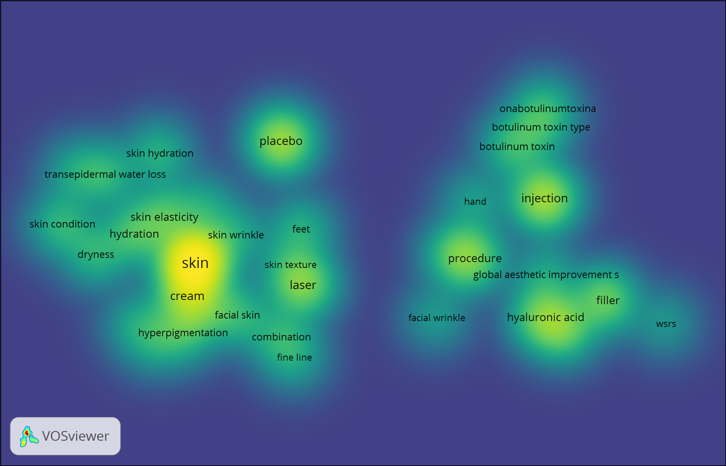

Connective tissue disorders (370 references)

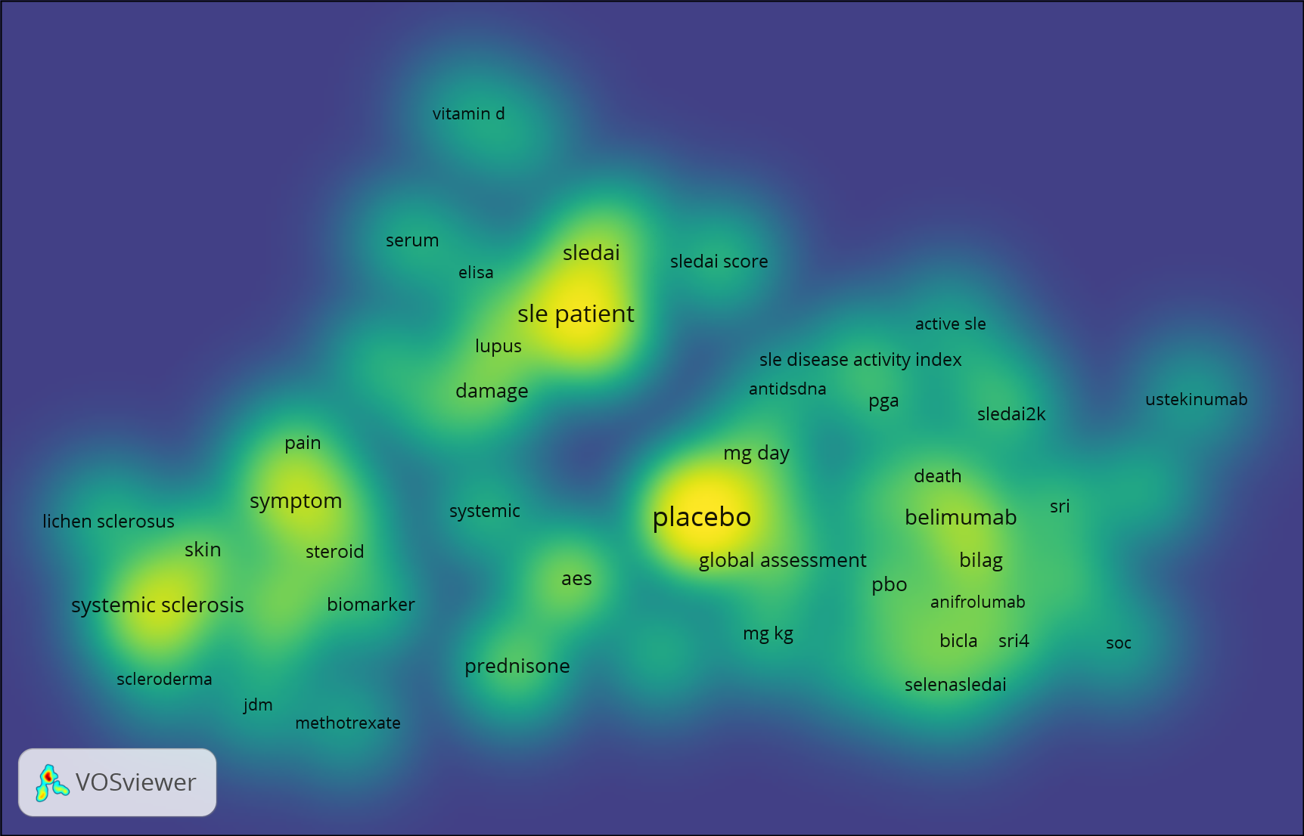
  - Other skin diseases – summary
Some new publications on hyaluronic acid, lichen sclerosus. Popular reviews on vitiligo, discoid lupus, rosacea.
New suggestions included:
Update #106 Interventions for pemphigus vulgaris and pemphigus foliaceus (2009)
Update #18 Interventions for bullous pemphigoid (2010) or #22 Interventions for mucous membrane pemphigoid and epidermolysis bullosa acquisita (2006, stable), both focused on non-steroid treatments.
Update #81 Interventions for hidradenitis suppurativa (2015)
Interventions for lymphomatoid papulosis
Update #24 Interventions for vitiligo (2015) focused/targeted
Interventions for hyperhidrosis (resuscitate #20)
Update #108 Topical interventions for genital lichen sclerosus (2011) focused on non-steroid treatments
Interventions for the management of radio/chemotherapy induced dermatitis of the head and neck (cancer group)
Update #25 Interventions for rosacea (2015)
Oral collagen supplementation for skin ageing
Efficacy of dermocosmetics
Safety of aesthetic injectables
Bathing or showering for dermatology patients (or for normal skin?) specific patient groups?
Interventions for dystrophic epidermolysis bullosa
  - Suggestions received during prioritisation which are not within Cochrane Skin scope
South American Satellite
Pediculosis
Scabies
Larva migrans
Myiasis
Other
Early detection of rheumatic diseases
Misdiagnosis and consequent mistreatment
Clinician/healthcare professional
Syphilis diagnosis
Misdiagnosis and consequent mistreatment
Clinician/healthcare professional
Disposable (vs washable) nappies for preventing napkin dermatitis in infants
Environmental as well as individual burden of dermatitis vs landfill
Clinician/healthcare professional & Researcher
(#51 Disposable nappies for preventing napkin dermatitis in infants (2006), now within the remit of the Cochrane Neonatal Group)

Appendix 1

The Cochrane Skin prioritisation survey

Cochrane Skin Prioritisation of Systematic Reviews 2020

About the survey
Thank you for your interest in responding to this survey. Cochrane Skin publishes systematic reviews about any aspect of skin disease management or prevention. Systematic reviews summarise existing evidence on specific research topics to inform clinical practice and policy questions.
We aim to dedicate our resources to covering topics with the highest priority and impact. To support this, we are currently undertaking a priority-setting exercise, which will help us determine topics for our reviews over the next three years. This process will involve looking at our existing titles, as well as new title suggestions from relevant stakeholders like you.
We want to know what research questions you would like to see answered about skin, hair and nail conditions. We are particularly interested in reviews that are key to informing guidelines or policy. Your suggestions will be considered along with those put forward by other survey respondents and will be prioritised by our editorial board. We will share the results of this exercise on our website.
Important information:
The survey contains 7 questions and should take 5-10 minutes to complete. All submissions will be kept confidential and data from this survey will only be accessible by the members of the Cochrane Skin Editorial Board. All personal identifiers will be removed from any final publication.
- If you have a colleague or contact whom you feel should complete the survey, please feel free to share the survey link with them.
- If you have any questions please contact Helen Scott, Assistant Managing Editor, at csg@nottingham.ac.uk.
Thank you for your valuable feedback!
The survey will be open until 31 January 2020.

*1. Please give your name

*2. Please give your email address

*3. I am answering the survey from the perspective of a:
- Patient/Consumer
- Patient group or consumer group (please specify)
- Caregiver or family member of a patient
- Clinician/healthcare professional
- Clinical society, association or professional organisation (please specify)
- Guideline developer (please specify)
- Policy or decision-maker (please specify)
- Researcher
Please specify the group/organisation you are representing, if relevant:

*4. Your personal information will be kept private and held securely. By submitting information you are agreeing to the use of the data by the Cochrane Skin editorial board for the prioritisation exercise. Is that OK?

5. What review(s) or update(s) would you like Cochrane Skin to prioritise over the next three years? You can list up to 5, most important first.

6. Why do you think these reviews are important?

7. Would you consider submitting a grant application in collaboration with Cochrane Skin, to lead one or more of these review titles? If so, please include the name of the review(s) and any other relevant details.

Table 3: Organisations invited to participate in the CS online survey

Type of organisation | Name of organisation
Consumer organisations | Vitiligo Society
 | Psoriasis Association
 | Psoriasis and Psoriatic Arthritis Alliance (PAPAA)
 | Acción Psoriasis
 | SPIN (Skin Inflammation & Psoriasis International Network)
 | Alopecia UK
 | Hidradenitis Suppuritiva Trust
 | National Eczema Society
 | L’Association Française de l’Eczéma
 | National Eczema Associations (US and Australia)
 | Nottingham support group for carers of children with eczema
 | Skin cancer awareness
 | Melanoma UK
 | DEBRA (Epidermolysis Bullosa)
 | Hyperhidrosis Support Group
 | Ichthyosis Support Group
 | Association for Lichen Sclerosus and Vulval Health
 | UK Lichen Planus
General Practitioners | Primary Care Dermatology Society (PCDS)
Policy makers and  guideline developers | World Health Organization
 | National Institute for Health and Care Excellence
 | British Association of Dermatologists
 | American Academy of Dermatology
 | European Academy of Dermatology and Venereology
 | European Dermatology Foundation
Mailing lists | Cochrane Skin
 | Cochrane Prioritisation website and lists
 | "Friends of the CEBD" Newsletter & CEBD Evidence Update
 | UKDCTN

Table 4: Summary of responses to Question 3: I am answering the survey from the perspective of…

Answer Choices | Responses (some respondents chose more than one category)
Clinician/healthcare professional | 48% | 21
Researcher | 41% | 18
Patient/Consumer | 18% | 8
Guideline developer | 14% | 6
Patient group or consumer group | 7% | 3
Clinical society, association or professional organisation | 7% | 3
Caregiver or family member of a patient | 0% | 0
Policy or decision-maker | 0% | 0
Total Respondents: |  | 44

Appendix 2

Table 5: Disability-adjusted life year (DALY) rate per 100 000 persons from 15 skin disease categories throughout 21 world regions, together with their global prevalence
Cause | Number of DALYs 2017 | Global prevalence 2017
Atopic Dermatitis | 9,003,374 | 2.79%
Psoriasis | 5,569,471 | 0.88%
Urticaria | 5,014,767 | 1.13%
Fungal infections of skin, nails and scalp | 4,154,505 | 10.09%
Viral infections of the skin | 4,032,963 | 1.77%
Acne vulgaris | 2,547,620 | 1.62%
Bacterial infections of the skin (pyoderma and cellulitis) | 2,274,455 | 1.17%
Contact Dermatitis | 1,989,159 | 1.08%
Malignant skin melanoma | 1,654,120 | 0.03%
Non-melanoma skin cancer (99.8% cutaneous squamous-cell carcinoma, 0.2% basal-cell carcinoma) | 1,329,250 | 0.03%
Pruritus | 755,573 | 0.97%
Alopecia areata | 523,059 | 0.22%
Cutaneous and mucocutaneous leishmaniasis | 263,646 | 0.06%
Seborrhoeic dermatitis | 135,606 | 0.14%
Leprosy | 31,513 | 0.01%
Other skin and subcutaneous diseases (includes e.g. bullous diseases, connective tissue diseases, and cutaneous drug reactions) | 3,107,688 | 7.47%
Total (1.69% of all causes) | 42,386,768

References to James Lind Alliance Priority Setting Partnerships and NICE research recommendations
Eczema
JLA PSP Top 10 (2012) http://www.jla.nihr.ac.uk/priority-setting-partnerships/eczema/
NICE research recommendations Atopic eczema in under 12s: diagnosis and management (2007) https://www.nice.org.uk/guidance/cg57/chapter/4-Research-recommendations
NICE research recommendations Frequency of application of topical corticosteroids for atopic eczema (2004) https://www.nice.org.uk/guidance/ta81/chapter/5-Recommendations-for-further-research
NICE research recommendations Tacrolimus and pimecrolimus for atopic eczema (2004) https://www.nice.org.uk/guidance/ta82/chapter/5-Recommendations-for-further-research
AAD Guidelines of care for the management of atopic dermatitis, Section 2. Management and treatment of atopic dermatitis with topical therapies; Section 3. Management and treatment with phototherapy and systemic agents; Section 4. Prevention of disease flares and use of adjunctive therapies and approaches (2014) https://www.aad.org/member/clinical-quality/guidelines/atopic-dermatitis
Psoriasis
JLA PSP (2018) for psoriasis (including scalp and nail, excluding palmoplantar pustular) top 10 priorities (2018) http://www.jla.nihr.ac.uk/priority-setting-partnerships/psoriasis/
NICE research recommendations Psoriasis: assessment and management (2017) https://www.nice.org.uk/guidance/cg153/chapter/2-Research-recommendations
Joint AAD-NPF guidelines of care for the management and treatment of psoriasis (biologics and comorbidities) (2019-20) https://www.aad.org/member/clinical-quality/guidelines/psoriasis
Acne
JLA PSP for acne (2014) top 10 priorities http://www.jla.nihr.ac.uk/priority-setting-partnerships/acne/
AAD acne clinical guideline (2016) https://www.aad.org/member/clinical-quality/guidelines/acne
Cellulitis
JLA PSP for cellulitis (2017) top 10 priorities http://www.jla.nihr.ac.uk/priority-setting-partnerships/cellulitis/
Melanoma
NICE research recommendations for Melanoma: assessment and management (2015) https://www.nice.org.uk/guidance/ng14/chapter/2-Research-recommendations
AAD guidelines for melanoma (2019) https://www.aad.org/member/clinical-quality/guidelines/melanoma
BCC and cSCC
AAD guidelines for BCC (2018) https://www.jaad.org/article/S0190-9622(17)32529-X/fulltext
AAD guidelines for cSCC (2018) https://www.jaad.org/article/S0190-9622(17)32530-6/fulltext
Hair Loss
JLA PSPs for Alopecia areata (includes totalis, universalis and barbae) and Hair Loss Disorders (excluding Alopecia areata) 2015 http://www.jla.nihr.ac.uk/priority-setting-partnerships/hair-loss/
Hidradenitis Suppurativa
JLA PSP for hidradenitis suppurativa (2013) top 10 priorities http://www.jla.nihr.ac.uk/priority-setting-partnerships/hidradenitis-suppurativa/
Vitiligo
JLA PSP for vitiligo (2013) top 10 priorities http://www.jla.nihr.ac.uk/priority-setting-partnerships/vitiligo/
Hyperhidrosis
JLA PSP for hyperhidrosis (2019) Top 10 priorities http://www.jla.nihr.ac.uk/priority-setting-partnerships/Hyperhidrosis/
Lichen Sclerosus
JLA PSP for lichen sclerosus (2018) Top 10 priorities http://www.jla.nihr.ac.uk/priority-setting-partnerships/lichen-sclerosus/
Dystrophic Epidermolysis Bullosa
JLA PSP for Dystrophic Epidermolysis Bullosa (Spain) (2012) http://www.jla.nihr.ac.uk/priority-setting-partnerships/dystrophic-epidermolysis%20-bullosa-spain/
Office-based surgery
AAD guidelines for office-based surgery (2016) https://www.aad.org/member/clinical-quality/guidelines/obs

Appendix 3

Search strategy used for CENTRAL. Results were limited to records added to CENTRAL between 2017 and 2019
#1 "Acta Dermato Venereologica":so
#2 "Acta Dermatovenerologica":so
#3 "Actas dermo-sifiliograficas":so
#4 "American Journal of Clinical Dermatology":so
#5 "American Journal of Dermatopathology":so
#6 "Anais brasileiros de dermatologia":so
#7 "Nederlands tijdschrift voor dermatologie en venereologie":so
#8 "Annales de dermatologie et de venereologie":so
#9 "Hong kong journal of dermatology and venereology":so
#10 "Giornale italiano di dermatologia e venereologia":so
#11 "Journal of the european academy of dermatology and venereology":so
#12 "Archives of dermatological research":so
#13 "Australasian journal of dermatology":so
#14 "BMC Dermatology":so
#15 "British Journal of Dermatology":so
#16 "Clinical Dermatology":so
#17 "Experimental dermatology":so
#18 "Pediatric dermatology":so
#19 "Cosmetic dermatology":so
#20 "JAMA dermatology":so
#21 "Clinical and Experimental Dermatology":so
#22 "Contact Dermatitis":so
#23 "Current Problems in Dermatology":so
#24 "Cutaneous and ocular toxicology":so
#25 "Cutis":so
#26 "Dermatitis":so
#27 "Dermatologic Clinics":so
#28 "Journal of clinical dermatology":so
#29 "Clinical, cosmetic and investigational dermatology":so
#30 "Annali italiani di dermatologia clinica e sperimentale":so
#31 "Journal of clinical and aesthetic dermatology":so
#32 "Dermatology online journal":so
#33 "Dermatologic Surgery":so
#34 "Dermatologic Therapy":so
#35 "Dermatology":so
#36 "Exogenous dermatology":so
#37 "European journal of dermatology":so
#38 Hautarzt:so
#39 "Indian Journal of Dermatology Venereology and Leprology":so
#40 "international journal of cosmetic science":so
#41 "international journal of dermatology":so
#42 "journal of the american academy of dermatology":so
#43 "journal of cosmetic dermatology":so
#44 "Journal of cosmetic and laser therapy":so
#45 "journal of cosmetic science":so
#46 "Journal of Cutaneous Medicine and Surgery":so
#47 "Journal of Cutaneous Pathology":so
#48 "Journal of Dermatological Science":so
#49 "journal of dermatology":so
#50 "Journal of Dermatological Treatment":so
#51 "journal of drugs in dermatology":so
#52 "Journal der Deutschen Dermatologischen Gesellschaft":so
#53 jddg:so
#54 "Journal of Investigative Dermatology":so
#55 "journal of tissue viability":so
#56 "lasers in surgery and medicine":so
#57 "lasers in medical science":so
#58 "melanoma research":so
#59 "Photodermatology Photoimmunology and Photomedicine":so
#60 "Photodermatology Photoimmunology & Photomedicine":so
#61 "Photodiagnosis and Photodynamic Therapy":so
#62 "Pigment Cell Melanoma Research":so
#63 "Seminars in Cutaneous Medicine and Surgery":so
#64 "skin pharmacology and physiology":so
#65 "skin research and technology":so
#66 "skin therapy letter":so
#67 skinmed:so
#68 {or #1-#67} with Publication Year from 2017 to 2019, in Trials
#69 (skin OR dermato* or psychodermatolog* OR dermatopatholog* or cutaneous OR mucocutaneous OR dermal OR dermis OR epidermal OR epidermo* OR epidermis OR cutis OR dermopathy OR sebaceous OR seborrheic OR seborrhoeic OR kerato* OR exanthem* OR rash* OR rashes OR eruption* OR erythema* OR bullous OR bullae OR bullosa OR bullosis OR blister* OR pustul* OR keloid* OR comedon* OR acne* OR rosace* OR eczema* OR dermatitis OR neurodermatitis OR pompholyx OR dyshidro* OR psoria* OR pustulosis OR plantaris OR palmaris OR sunscreen OR sunscreens OR "sun screen" OR "sun screens" OR "sun protection" OR "sunburn" OR "sun burn" OR melanoma OR melanomas OR melanocyt* OR non-melanoma OR nonmelanoma OR "basal cell" OR "squamous cell" OR intra-epidermal OR intraepidermal OR bowen* or Merkel OR kaposi* OR actinic OR (lymphoma* near skin) OR (lymphoma* near cutaneous) OR lichen* OR hidradenitis OR prurit* OR prurigo OR lupus OR pemphigus OR pemphigoid OR pyoderma* OR cellulitis OR erysipelas OR impetigo OR ecthyma OR folliculitis OR dermatomyco* OR mycosis OR mycoses OR mycotic OR dermatophyt* OR tinea OR "athletes foot" OR "athletes' foot" OR "athlete's foot" OR onych* OR kerion* OR chancr* OR molluscum OR herpeti* OR cold sore* OR wart* OR verruc* OR "cutaneous leishmaniasis" OR urticaria* OR "stevens johnson" OR "toxic epidermal necrolysis" OR angioedema OR pityriasis OR genodermatos* OR albin* OR icthyo* OR xero* OR epidermolysis OR porphyria* OR protoporphyria* OR mucinos* OR porokerato* OR granuloma* OR hyperkerato* OR acanthosis OR dermatomyositis OR scleroderma OR scleredema OR panniculitis OR (cutaneous near vasculitis) OR ("polyarteritis nodosa" near cutaneous) OR lymphoedema OR lymphedema OR (abscess* near cutaneous) OR (abscess* near skin) OR boils OR hyperhidro* OR sweat* OR nail* OR toenail* OR paronychia OR chilblain* OR pernio* OR hirsut* OR hypertrichosis OR alopecia OR baldness OR balding OR cheilitis OR aphthous OR (pigmentation near skin) OR hypopigmentation OR hyperpigmentation OR vitiligo OR melasma OR leukoderma OR leucoderma OR "birth mark" OR "birth marks" OR birthmark* OR mole OR moles OR nevus OR naevus OR nevi OR naevi OR haemangioma* OR hemangioma* OR angioma* OR papilloma* OR dermatofibroma* OR angiokeratoma* OR acanthoma*):ti with Publication Year from 2017 to 2019, in Trials
#70 [mh ^skin[mj]] OR [mh ^dermatology[mj]] OR [mh ^“skin diseases”] OR [mh ^”skin abnormalities”] OR [mh ^"skin physiological processes"] OR [mh ^dermis] OR [mh ^epidermis] OR [mh ^"dermatitis seborrheic"] OR [mh ^keratosis] OR [mh ^exanthema] OR [mh ^erythema] OR [mh ^blister] OR [mh ^keloid] OR [mh ^"acne vulgaris"] OR [mh ^"acneiform eruptions"] OR [mh ^rosacea] OR [mh ^"dermatitis atopic"] OR [mh ^eczema] OR [mh ^dermatitis] OR [mh ^neurodermatitis] OR [mh ^"eczema dyshidrotic"] OR [mh ^psoriasis] OR [mh ^"sunscreening agents"] OR [mh ^"skin aging"] OR [mh ^"nevi and melanomas"] OR [mh ^melanoma] OR [mh ^"carcinoma basal cell"] OR [mh ^"carcinoma squamous cell"] OR [mh ^"bowen's disease"]
#71 [mh ^”neoplasms adnexal and skin appendage”] OR [mh ^”skin neoplasms”] OR [mh ^”carcinoma merkel cell”] OR [mh ^”sarcoma kaposi”] OR [mh ^”keratosis actinic”] OR [mh ^”urticaria pigmentosa”] OR [mh ^”mastocytosis cutaneous”] OR [mh ^“histiocytosis”] OR [mh ^hemangiosarcoma] OR [mh ^“lichenoid eruptions”] OR [mh ^hidradenitis] OR [mh ^pruritus] OR [mh ^prurigo] OR [mh ^“lupus erythematosus cutaneous”] OR [mh pemphigus] OR [mh ^“pemphigoid bullous”] OR [mh ^pyoderma] OR [mh ^“soft tissue infections”] OR [mh ^cellulitis] OR [mh ^erysipelas] OR [mh ^impetigo] OR [mh ^ecthyma] OR [mh ^folliculitis]
#72 [mh ^dermatomycoses] OR [mh ^tinea] OR [mh ^“tinea pedis”] OR [mh ^onychomycosis] OR [mh ^“molluscum contagiosum”] OR [mh ^“herpes labialis”] OR [mh ^“herpes simplex”] OR [mh ^“herpes zoster”] OR [mh ^warts] OR [mh ^phthiraptera] OR [mh ^“leishmaniasis cutaneous”] OR [mh ^urticaria] OR [mh ^angioedema] OR [mh ^pityriasis] OR [mh ^“skin diseases genetic”] OR [mh ^albinism] OR [mh ^ichthyosis] OR [mh ^porphyrias] OR [mh ^mucinoses] OR [mh ^dermatomyositis] OR [mh ^“scleroderma systemic”] OR [mh ^“scleroderma localized”] OR [mh ^“cutis laxa”] OR [mh ^lymphedema] OR [mh ^furunculosis] OR [mh ^hyperhidrosis] OR [mh ^sweating] OR [mh ^“nail diseases”] OR [mh ^paronychia] OR [mh ^“hair diseases”]
#73 [mh ^hair] OR [mh ^hirsutism] OR [mh ^hypertrichosis] OR [mh ^alopecia] OR [mh ^cheilitis] OR [mh ^“skin pigmentation”] OR [mh hyperpigmentation] OR [mh ^“pigmentation disorders”] OR [mh ^hypopigmentation] OR [mh ^vitiligo] OR [mh ^melanosis] OR [mh ^nevus] OR [mh ^“nevus pigmented”] OR [mh ^hemangioma] OR [mh ^angiokeratoma] OR [mh ^erythrasma]
#74 #70 or #71 or #72 or #73 with Publication Year from 2017 to 2019, in Trials
#75 #68 or #69 or #74 with Publication Year from 2017 to 2019, in Trials

Limitations of the search
- For this prioritisation exercise, only the CENTRAL database was searched. CENTRAL may not be a comprehensive source of reports of trials published in the scope of Cochrane Skin.
- Not all retrieved references are confirmed reports of randomised controlled trials.
- Screening and categorisation of results was undertaken by one person. A second person screening and categorising the results of the search would have increased the rigor and accuracy of this process.

Screen shots showing EndNote folders

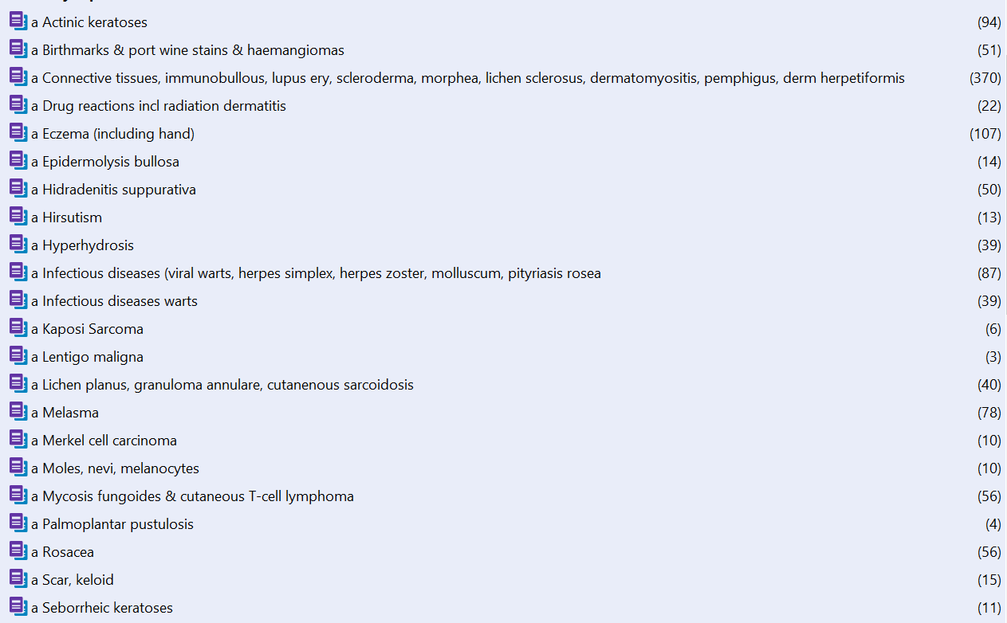
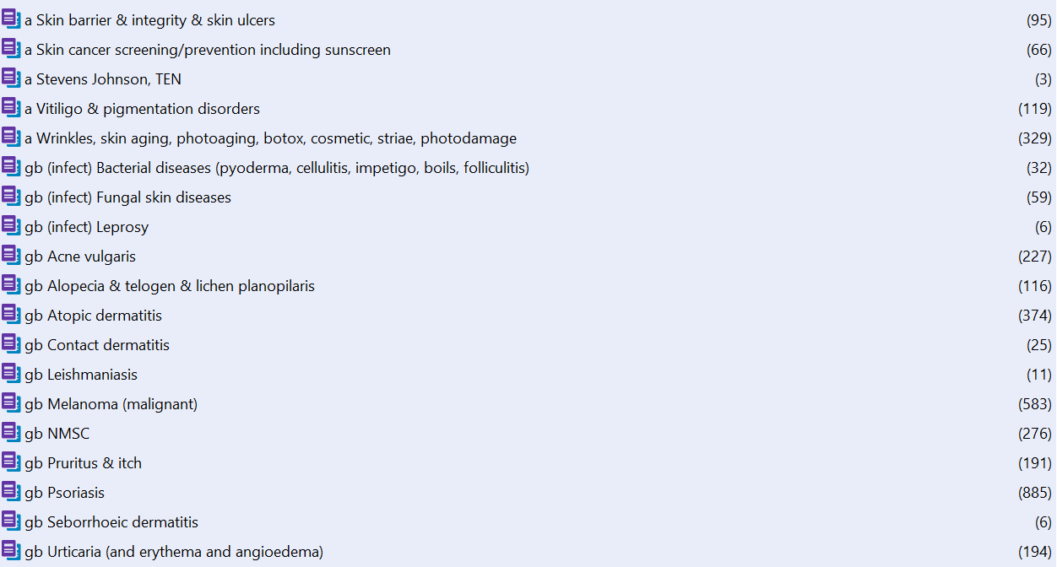

Appendix 4

Limitations of VOSViewer maps
1. Text mining software works best on large volumes of text, and so it was not appropriate for analysing references form all topic areas within the scope of Cochrane Skin. It is important to note that disease areas with low numbers of references assigned to them which have not been subject to text mining, might still have important, practice changing trials associated with them.
2. VOSViewer uses title and abstract text as a source for the maps. If a reference’s title does not reflect the content of the study being reported, or if an abstract is not available, the accuracy of the analysis may be affected.
3. For this study, only the CENTRAL database was searched. CENTRAL may not be a complete source of reports of trials in the scope of Cochrane Skin.
4. Screening of results was undertaken by one person. A second person screening and categorising the results of the search would have increased the rigor of this process.

VOSViewer map showing high frequency words across all records retrieved from CENTRAL related to the scope of Cochrane Skin
The brightest, largest text signifies the words most frequently appearing in the references. This map was generated from text and abstract text from all references retrieved by the CENTRAL search (4594 references).
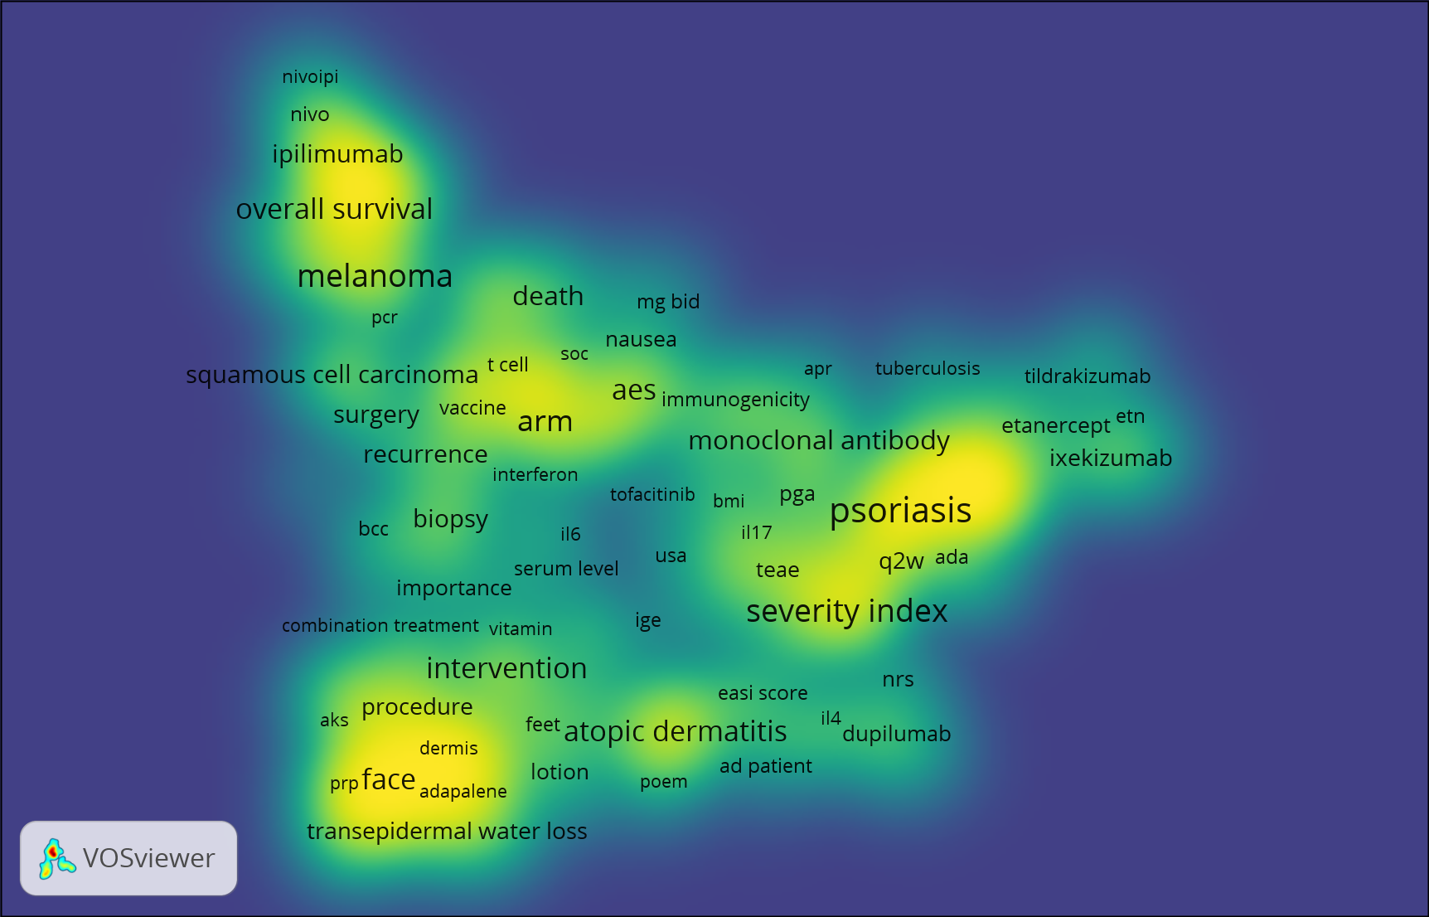

http://www.healthdata.org/gbd/about
http://ghdx.healthdata.org/gbd-results-tool
According to the World Health Organization, one DALY can be thought of as one lost year of "healthy" life. DALYs for a disease or health condition are calculated as the sum of the Years of Life Lost (YLL) due to premature mortality in the population and the Years Lost due to Disability (YLD) for people living with the health condition or its consequences. https://www.who.int/healthinfo/global_burden_disease/metrics_daly/en/

